**CCT College Dublin**

**Assessment Cover Page**

| **Module Title:** | Strategic Thinking |
| --- | --- |
| **Assessment Title:** | CA 2 - Capstone Project Continued |
| **Lecturer Name:** | James Garza |
| **Student Full Name:** | Kavi Patak |
| **Student Number:** | sba22391 |
| **Assessment Due Date:** | 17 December 2023 |
| **Date of Submission:** | 22 December 2023 |



**Declaration**

| By submitting this assessment, I confirm that I have read the CCT policy on Academic Misconduct and understand the implications of submitting work that is not my own or does not appropriately reference material taken from a third party or other source. I declare it to be my own work and that all material from third parties has been appropriately referenced. I further confirm that this work has not previously been submitted for assessment by myself or someone else in CCT College Dublin or any other higher education institution. |
| --- |

**_______________________________________________________________________**

# Leveraging Machine Learning and Data Science

# for Competitive Advantage:

Estimating Player Market Values

**_______________________________________________________________________**

by Kavi Patak

sba22391

Strategic Thinking (M1)

Lecturer: James Garza

CCT College, Dublin

May 12, 2024

**_______________________________________________________________________**

**_______________________________________________________________________**

# Table of Contents

**Leveraging Machine Learning and Data Science** **for Competitive Advantage:**

**Estimating player market values**

**Table of Contents**

**Introduction 3**

**Problem Domain and Objectives 3**

**Scope and Methodology 4**

Consolidating and Characterising the Data 4

Exploratory Data Analysis (EDA) 7

Player Market Values Over Time 7

Current Player Market Density 8

Player Market Values by Domestic Competition 9

Player Market Values by Position 10

Player Market Values by Age 11

Player Market Values by Goals Scored 12

Player Market Values by Goals Assisted 13

Player Market Values by Clean Sheets 14

Data Preprocessing 15

Feature Engineering 17

Model Selection 19

Training and Validation 19

Evaluation Metrics 19

Tune Hyperparameters 20

Predictive Analytics 20

Visualisation 20

Continual Improvement 20

Boundaries and Limitations 20

**Results 21**

**Timeline 22**

**Conclusion 22**

**Appendix A 22**

**Appendix B 33**

**Appendix C 35**

**Appendix D 37**

**References 38**

**_________________________________________________________________________**

# Introduction

Organisations have historically implemented enterprise systems such as enterprise resource planning in attempts to gain a competitive advantage (Goundar, 2021). The advent of the internet and proceeding developments in technologies like the Internet of Things(IoT), cloud computing, block chain, big data, Machine Learning (ML) and Artificial Intelligence (AI), have heavily influenced enterprises systems of today, and opened new avenues for conducting business.

Organisations have realised the potential value that resides in data and thus search for ways of utilising this valuable asset, it is here that Business Intelligence (BI) has become an important concept (Agarwal & Dhar 2014, cited in Persson and Sjöö, 2017). BI is an organisation's ability to effectively use the information it collects from daily enterprise.

(Vidal-García et al., cited in Niu et al., 2021). By identifying emerging opportunities, highlighting potential risks, providing useful insights and supporting decision making, ensure BI plays a significant role in optimising organisational effectiveness (Zhao et al., cited in Niu et al., 2021).

The role of analytics in football has evolved over the past decade, and will continue to do so. Technological developments continue to improve the volume and quality of data available to the world’s leading clubs, as well as the ability to derive insight from them. The opportunity exists for clubs of all sizes to use analytics to build a sustainable competitive advantage, something which will be most evident in the area where they invest most: the transfer market.

Having previously assessed the potential for a club to gain a competitive advantage through AI by means of Porter's Five Force Framework (Patak, 2023), this research will focus on leveraging machine learning and data analytics in player scouting and recruitment. More precisely, this report will outline the proposed steps in developing a football player value assessment model using machine learning techniques and in doing so, aid a football club in making more objective and data driven transfer decisions.

This research project will follow the Cross-Industry Standard Process for Data Mining (CRISP-DM) approach in iterating through the stages of Business Understanding, Data Understanding, Modelling, Evaluation and Deployment.

# Problem Domain and Objectives

The first phase of the CRISP-DM lifecycle calls for an understanding of the domain and business objectives, and extracting from this the requirements and goals for this project (Wirth and Hipp, 2000).

Football is a highly lucrative sport which depends heavily on the services of football players, the main suppliers to a football club (Patak, 2023). It is therefore no surprise that the majority of a club's expenditure is on player transfers and wages, with smaller clubs unable to compete financially with their larger counterparts (Metelski, 2021). Furthermore, the consequences of poor scouting and recruitment can be devastating to a club, regardless of size, and can have adverse affects not only from a business perspective (Depken and Globan, 2020), but to squad harmony, on pitch result, and even to a clubs reputation.

This project aims to level the playing field, at least financially in the transfer market, by developing a machine learning model to estimate the market value of football players based on various features such as age, goals, assists and other contributing factors.

Hypothesis: A fair and accurate player market value can be estimated through ML from the available features within the selected dataset.

In addition to this core objective, this project aims to provide insights into promising players who may be undervalued in the market. In-depth analyses shall be conducted on player performance data in specific positions, based on certain physical attributes, as well as exploring the relationship between a players age, value and statistics.

Finally, this project will compare the market value within different domestic leagues and investigate any changes in player market values over time.

# Scope and Methodology

Having developed a business understanding of the task at hand, and following the CRISP-DM methodology, the remaining steps in the development lifecycle call for Data Understanding, Modelling, Evaluation and Deployment.

The CRISP_DM methodology is “Agile” in nature, and unlike the traditional linear Waterfall lifecycle, the sequence of phases is not strict (Wirth and Hipp, 2000). In identifying a viable use case for this capstone project, both the Business Understanding and Data Understanding stages had been initiated as one is intrinsically linked to the other. A brief exploration of the datasets has been conducted to confirm that it will satisfy its need.

Continuing on from that and adhering to the CRISP_DM lifecycle, the following processes will be carried out and discussed in this report:

* Consolidating and Characterising the Data,
* Exploratory Data Analysis (EDA),
* Data Preprocessing,
* Feature Engineering,
* Model Selection,
* Training and Validation,
* Defining Evaluation Metrics,
* Tuning Hyperparameters,
* Predictive Analytics,
* Producing Visualisations,
* Further iterations and improvements.

### Consolidating and Characterising the Data

The selected dataset is called “Football Data from Transfermarkt” provided by Kaggle and available at: <https://www.kaggle.com/datasets/davidcariboo/player-scores/versions/284>

This dataset consists of nine CSV files with information on football competitions, games, clubs, players and player appearances. Each dataset contains a vast amount of observations (entries or rows) and numerous features (columns, attributes or variables), much too many to individually name. So too for missing and duplicate values. A more detailed overview of each file's feature names, data types, unique value counts and statistical makeup of numerical features, and missing values can be found in appendix A. A schema of the database design with attributes of the entity and the ID’s that are used to join them can also be found in the appendix. EDA and initial preprocessing is performed on individual datasets before merging the required data for further processing and modelling. The appearances dataset contains valuable performance statistics which needed to be collated along with game and player attributes. Following failed attempts at merging the data, I was fortunate to find a coding solution which I modified for my use. The code was originally provided by Luis Gasper Cordeiro and found on David Coxon’s kaggle webpage (Cordeiro, n.d., in Coxen, n.d.). The consolidated datasets general information can be seen in figure 1.2 below.

|  |
| --- |

Figure 1. Merged data general information

### Exploratory Data Analysis (EDA)

EDA is a process of examining the available data to discover patterns of correlation, identify trends, and gain insights of interest. It aids in spotting anomalies, testing hypotheses and clarifying any assumptions (Suresh Kumar Mukhiya and Ahmed, 2020). Initial EDA is performed by utilising Pandas Profiling which generates a comprehensive profile report on the data. The report consists of an overview of the datasets statistics, missing values, duplicates, attributes, as well as the correlation between variables. It is a quick and easy way to assess the data, especially with large datasets. This process aids in identifying outliers within the players dataset, with two player height values considerably lower than the mean for that attribute. These values were thus replaced with the correct values sourced from the transfermarkt website. On this second iteration, on the consolidated data, we analyse the frequency distribution of ‘market_value_in_eur’, the target variable more closely. Plotting the distribution using a Seaborn histogram (Figure 2) we find the data to be right skewed. Three transformations in Box Cox, square root and log are applied in attempts to achieve a Gaussian distribution, with the latter being the most successful (Figure 3). Univariate analysis continues by investigating the distribution of all numerical variables. Apart from a player's height, they too do not follow a normal distribution. Boxplots are created which highlight the existence of outliers, while also displaying the variance and spread of quantitative variables. The findings of this added analysis proves invaluable in selecting the most suitable preprocessing methods for maximising ML modelling results. With the ultimate objective of evaluating a players market value, thorough EDA using numerous graphs including scatterplots, barcharts, histograms, pie charts and boxplots were leveraged in plotting different categorical variables against player market value. The transfer market itself was first analysed for changes in market values over time and the players market distribution by position, footedness and age group.

#### Player Market Values Over Time

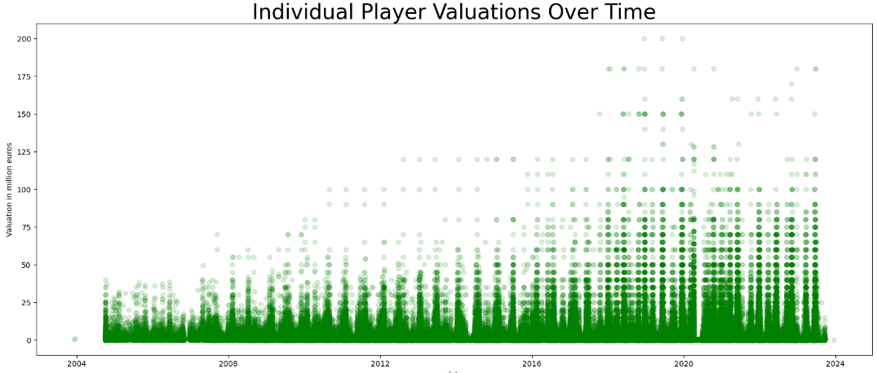

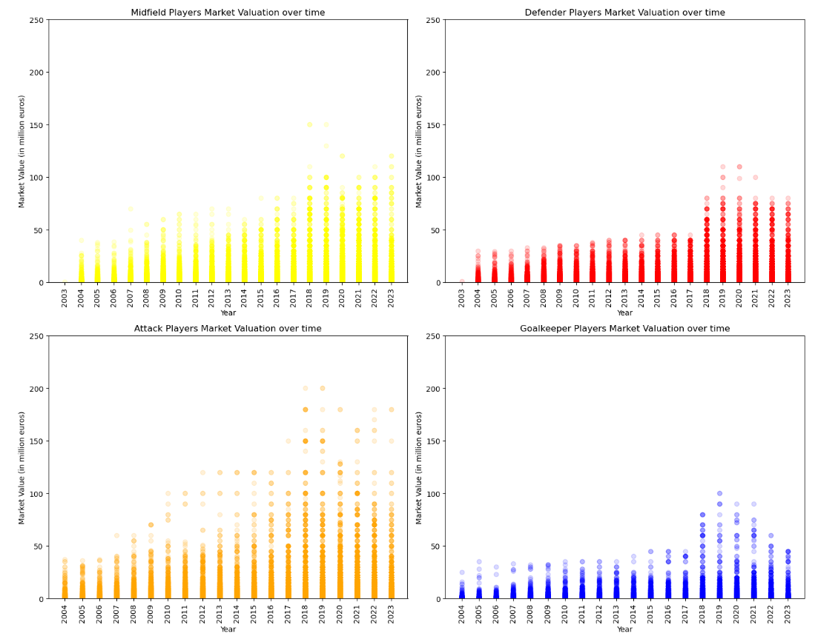

Figure 1.3. Individual player market values over time

For the individual player transfer market values above (figure 1.3 ) we see a strong positive relationship between the market value and year from 2004 to 2019 with a steady increase until falling off in the last three years.

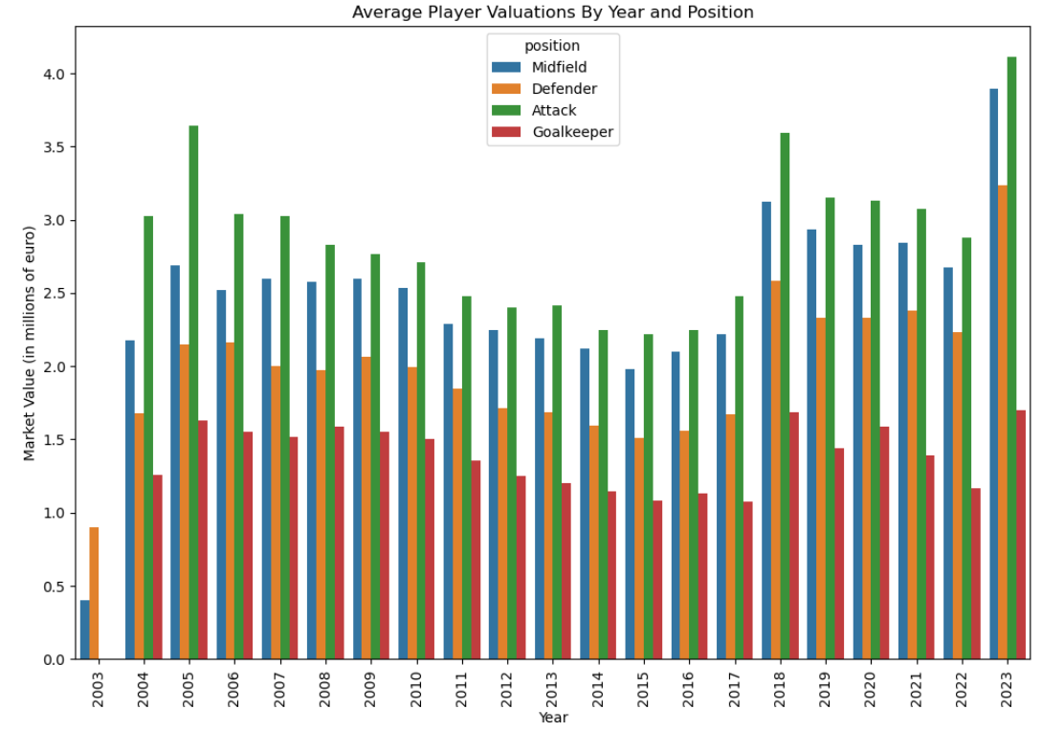

Figure 1.4. Averaged player market value changes over time

The averaged player market values over the same time is nonlinear with peaks in 2005, 2018 and 2023 and lows in 2003 and 2015 (Figure 1.4).

#### Current Player Market Distribution

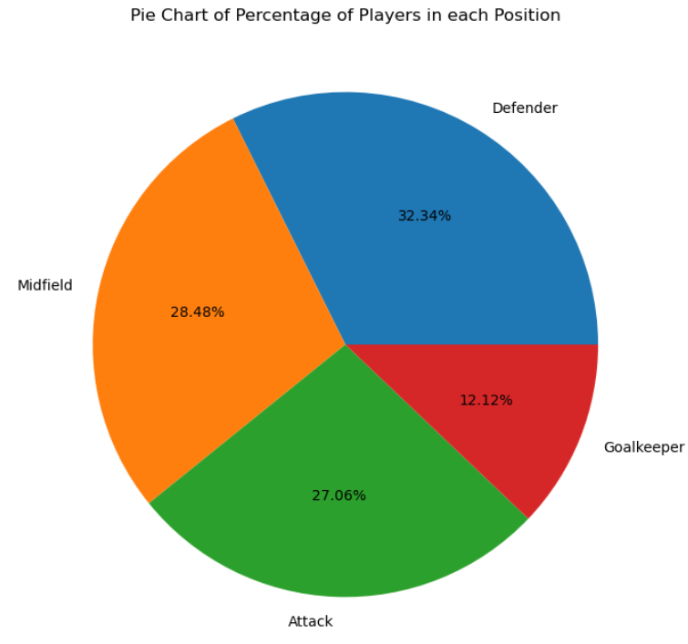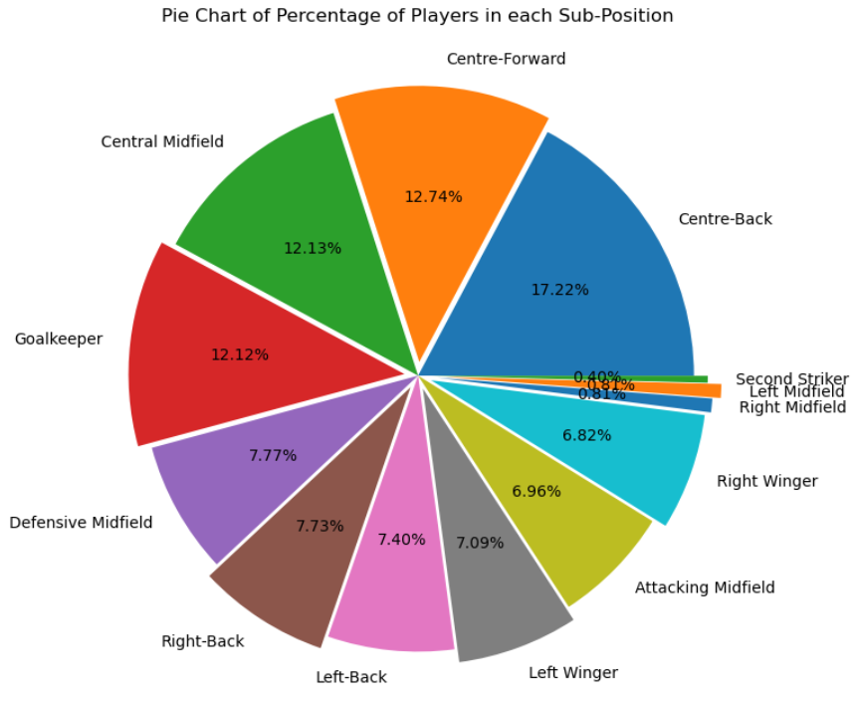

Figure 1.5. Current market density by position

The pie chart above illustrates that the market of currently playing players is evenly distributed between Attack, Midfield and Defence. There are fewer players in the goalkeeper position which is to be expected as only one goalkeeper is ever selected in a starting eleven.

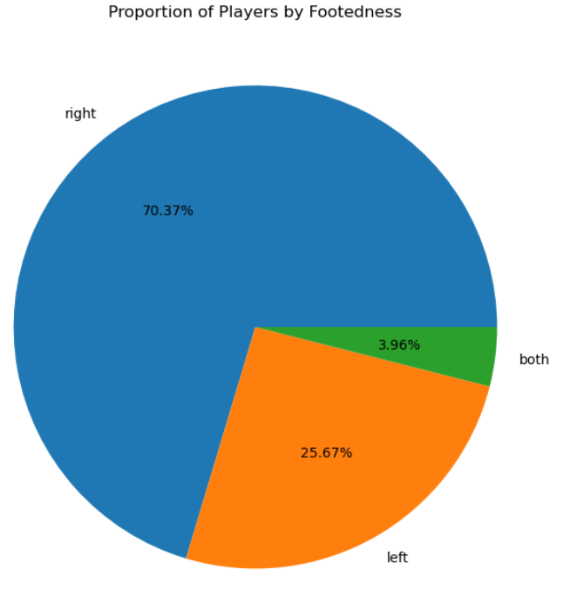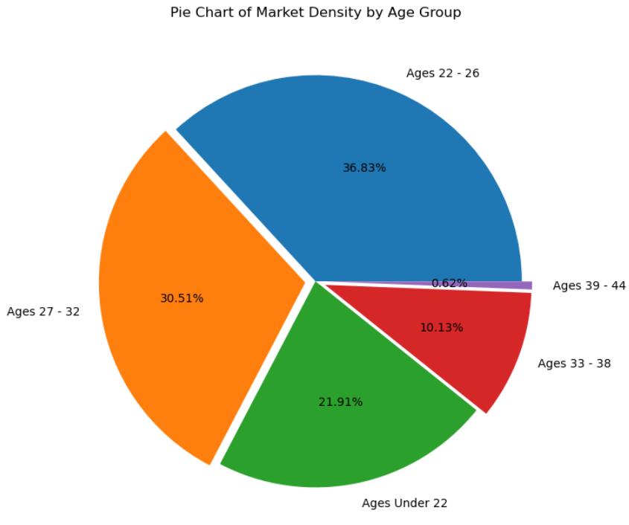

Figure 1.6. Current market density by footedness on the left and age group on the right

We can see from the pie chart above left that the large majority of players are right footed. Only 25.67% are left footed which along with the 3.96% for both footed players may contribute to a higher market value due to scarcity.

As one would expect, approximately 67% of the player market is of players aged between 22 and 32 which is generally considered a players prime years. 21.91% consists of younger up and coming players with roughly 10% of players in the twilight of their professional careers.

#### Player Market Values by Domestic Competition

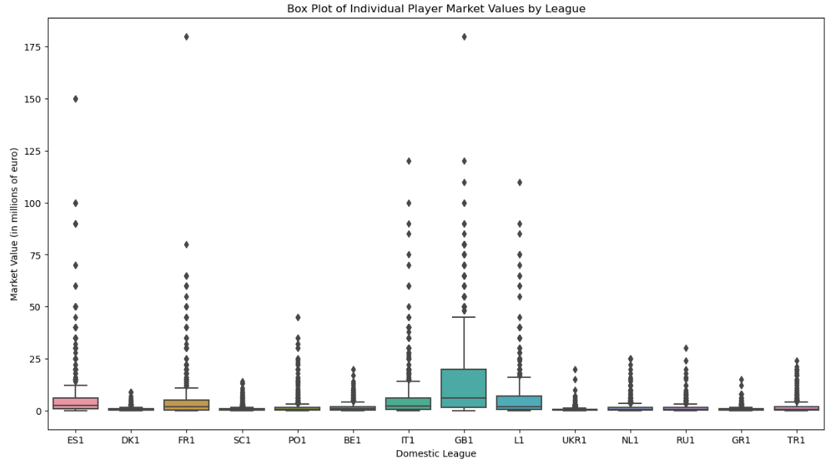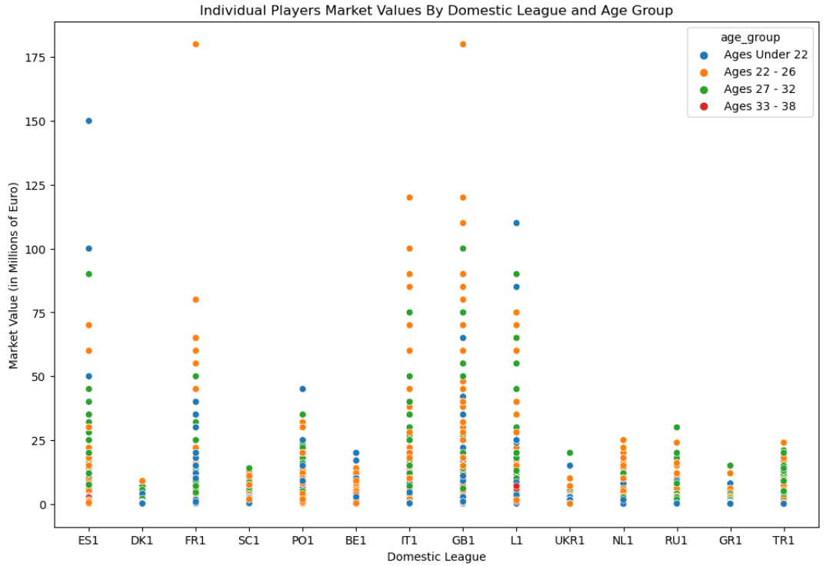

Figure 1.7. Boxplot of individual market values by domestic competition on the left and scatterplot of market value by age group on the right

The highest valued players currently play in LaLiga (Spain - ES1), Ligue 1 (France - FR1), Serie A (Italy - IT1), Premier League (England - GB1) and Bundesliga (Germany - L1). All five leagues also contain players whose market values far exceed the average within those leagues. This box plot also highlights the outliers with regards to market value within each league (figure 1.7 left).

From the scatterplot on the top right we see that the highest valued players are generally under 27 years of age across all domestic competitions (figure 1.7 right).

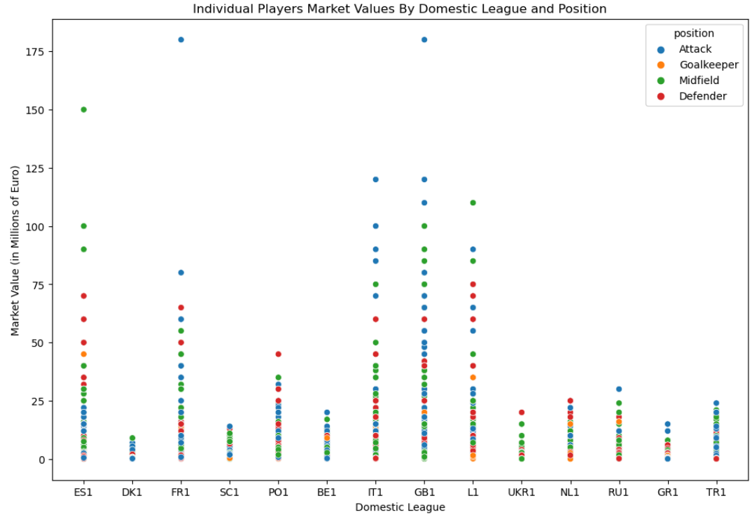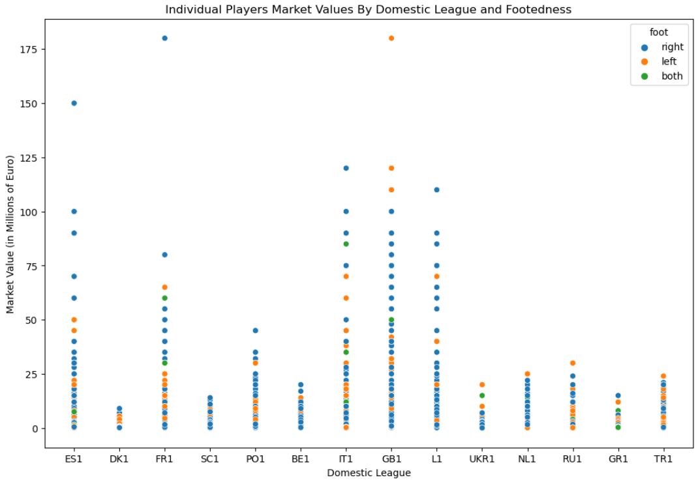

Figure 1.8.Individual player market values for each domestic competition

Attackers and Midfielders are valued the highest with Goalkeepers generally valued the lowest. Left footed players are highly valued relative to their market density. Three of the top seven highest valued players are left footed. Additionally they all apply their trade in the English Premier League (figure 1.8).

#### Player Market Values by Position

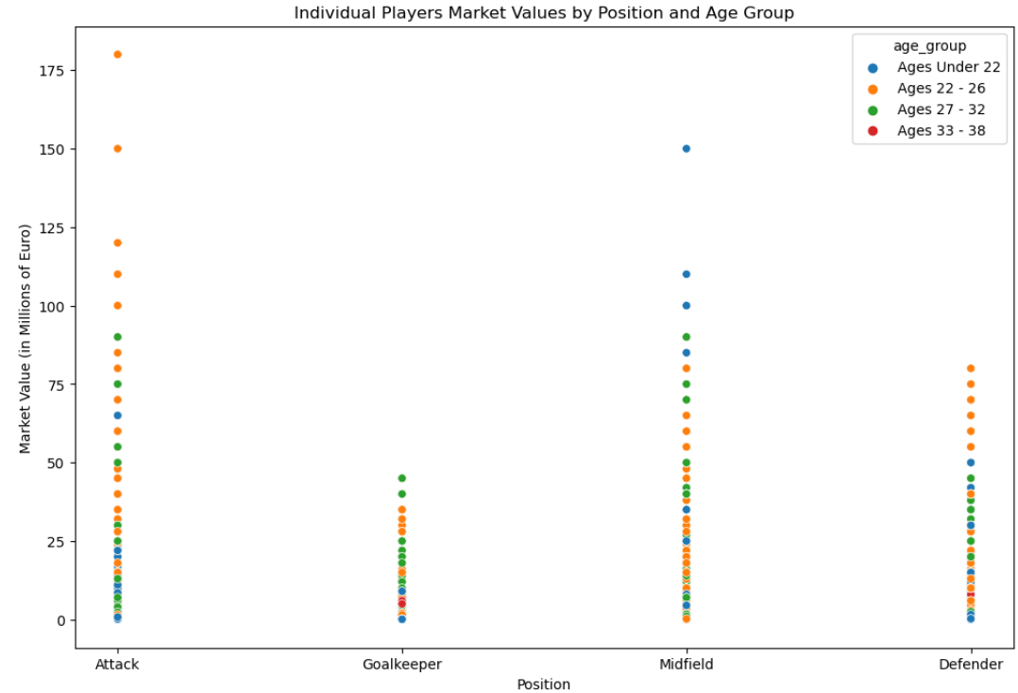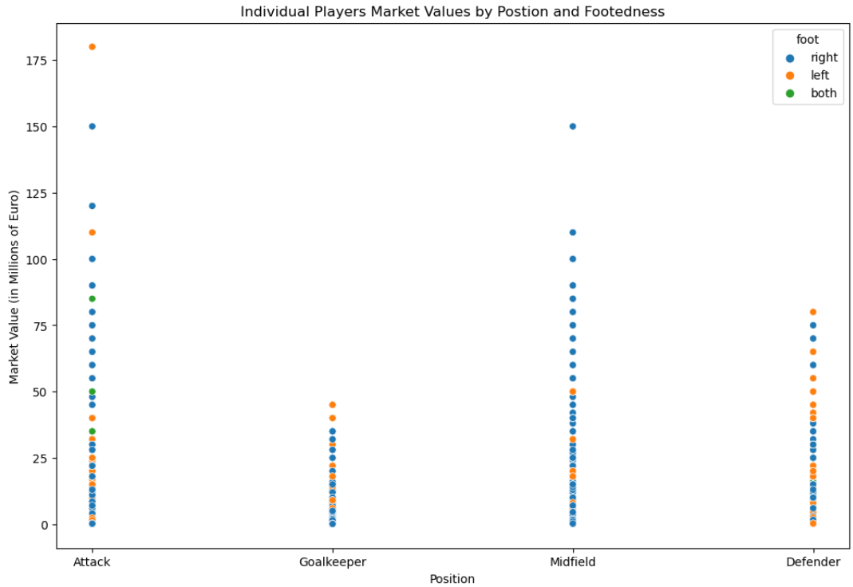

Figure 1.9. Individual player market values by position

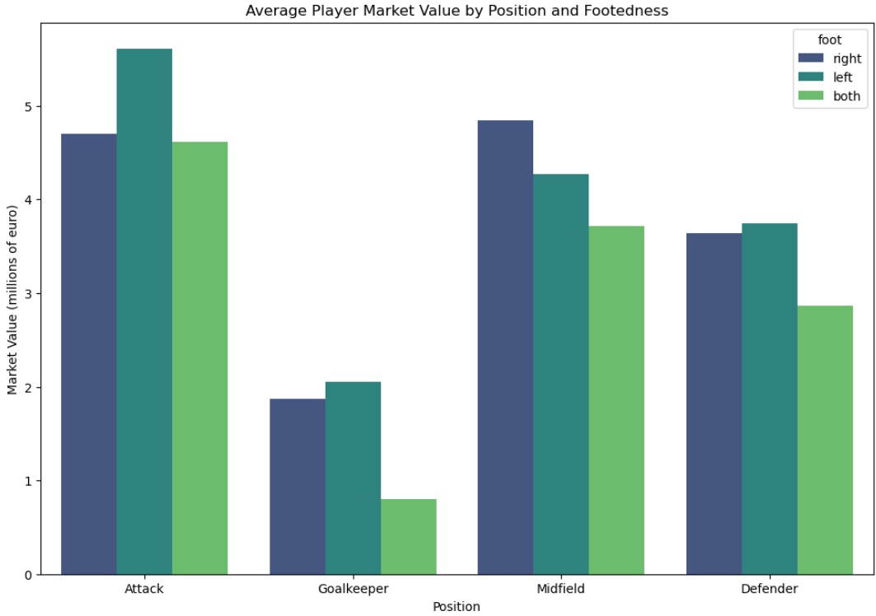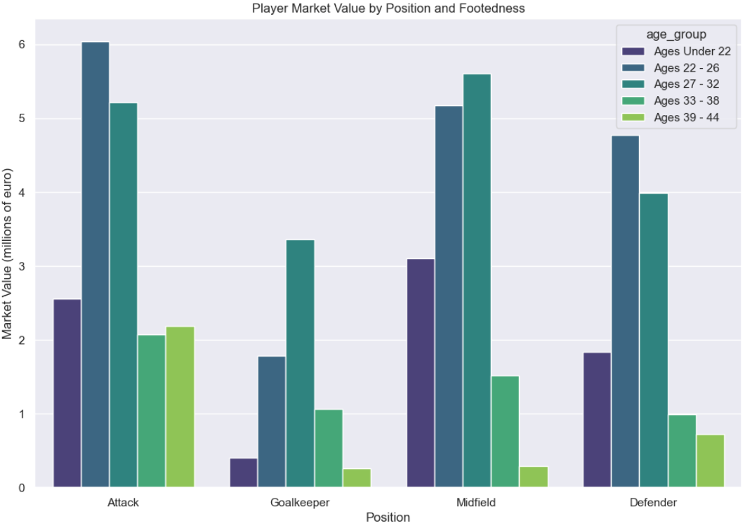

Figure 2.0. Averaged player market values by position, foot and age group

Left footed attackers seem to be valued the highest on average (figure 2.0 left). This is little surprise following earlier analysis of current players and their footing which showed that only 25.67% of current players are left footed. There is clearly a shortage and demand for such players. The highest valued age category appears to be between the ages of 22 and 26. However in the goalkeeping department, age and experience is slightly more valued (figure 2.0 right).

#### Player Market Values by Age

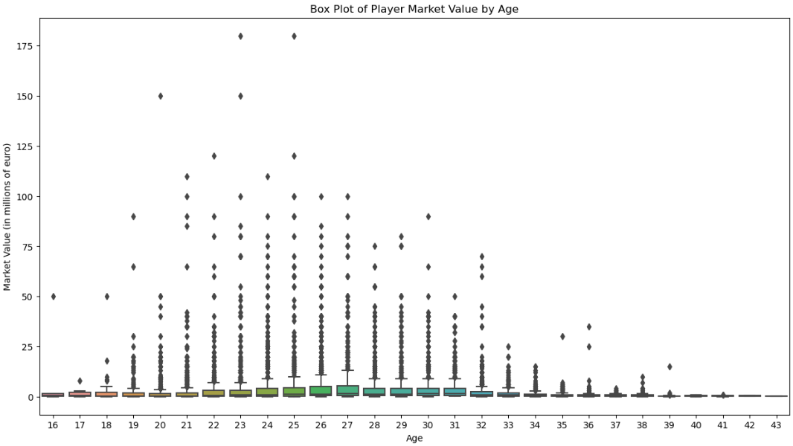

Figure 2.1. Individual player market values by age

We see that the highest valued players at around 100 million euro or more are aged between 20 and 27 years (figure 2.1).

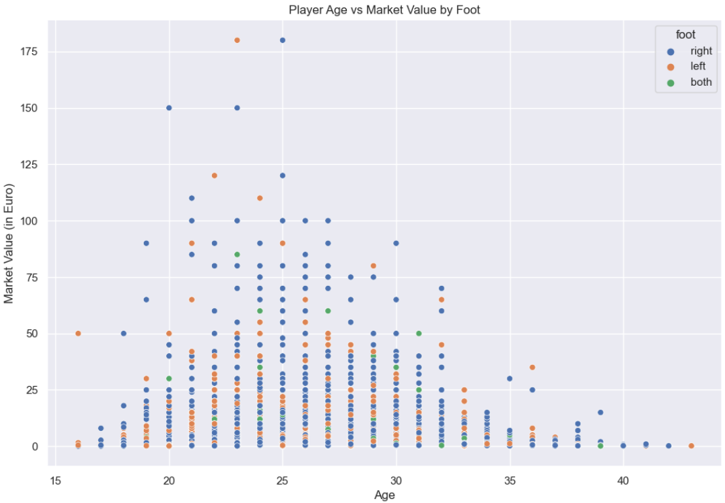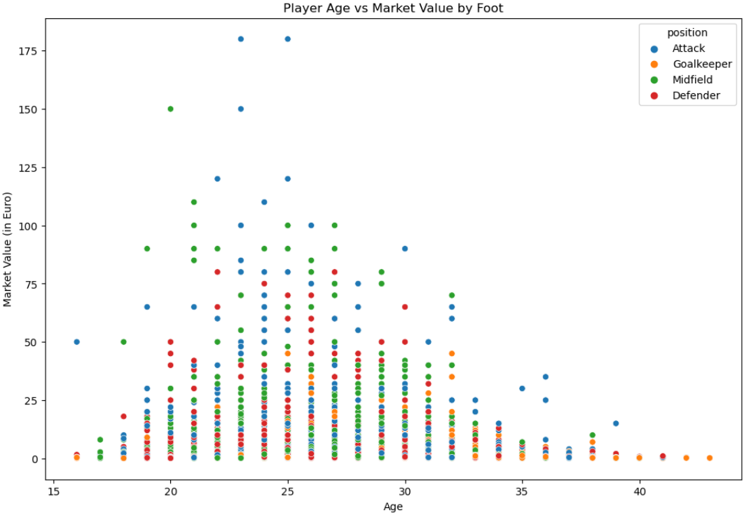

Figure 2.2. Individual player market values by age, footedness (left) and position (right)

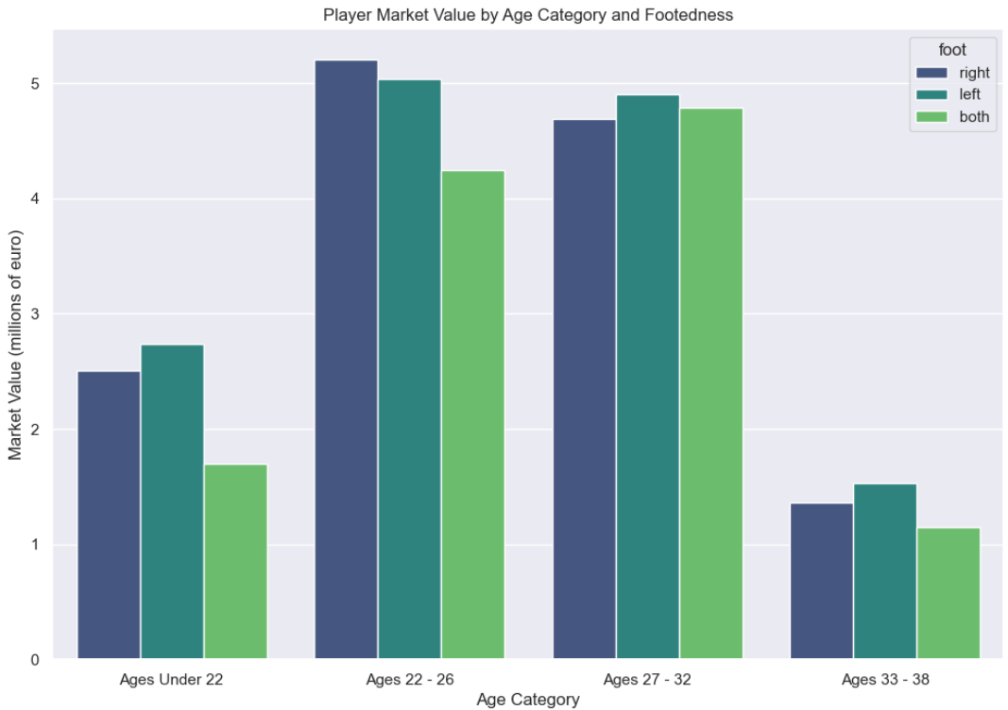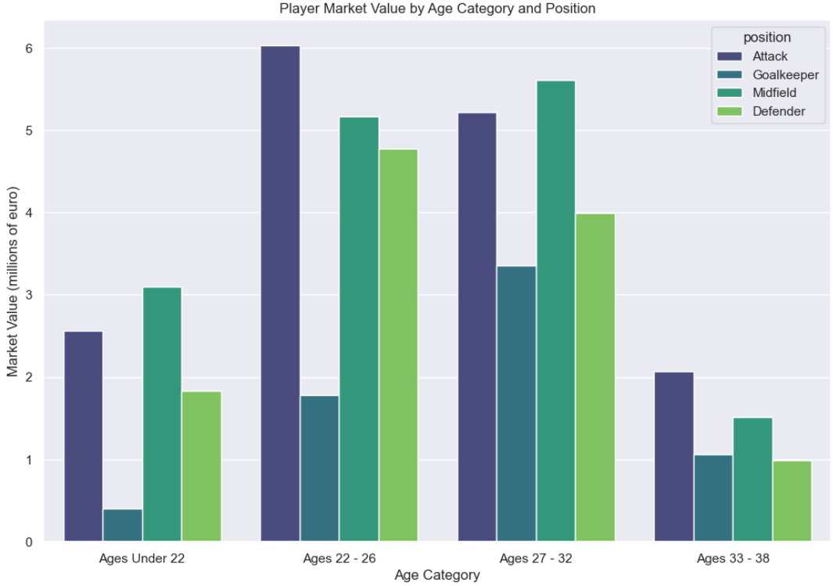

Figure 2.3. Averaged player market values by age, footedness (left) and position (right)

Across all domestic leagues, players of all footedness average a higher price between the ages of 22 and 32. The average market value of players is around 5 million or under across all leagues (figure 2.3 left). The highest average market value across all leagues is for attackers aged between 22 and 26 with an average value of around 6 million euro. Midfielders are valued higher on average between the ages of 27 and 32 years old (figure 2.3 right).

#### Player Market Values by Goals Scored

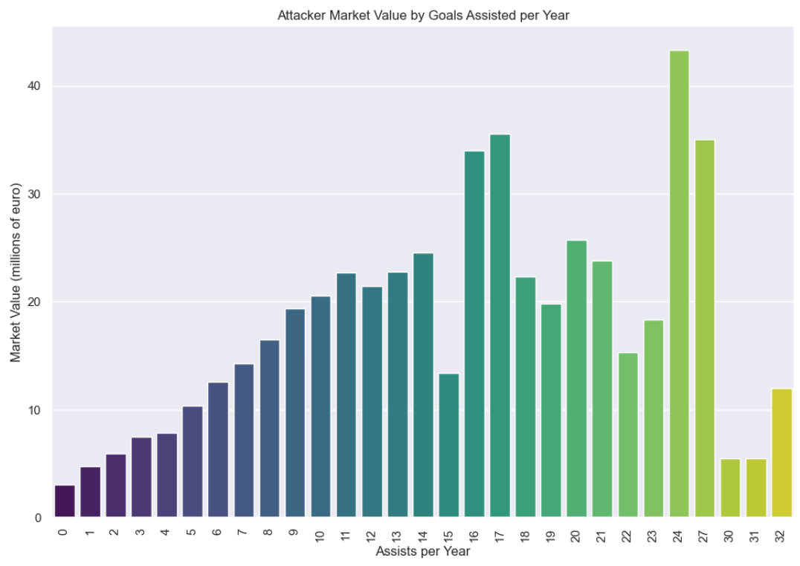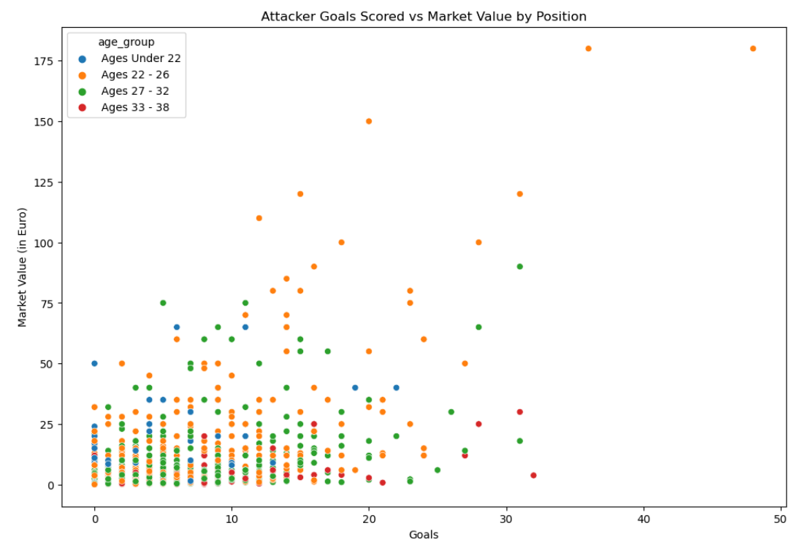

Figure 2.4. Averaged attacker market values by goals (left) and individual attacker market values by goals (right)

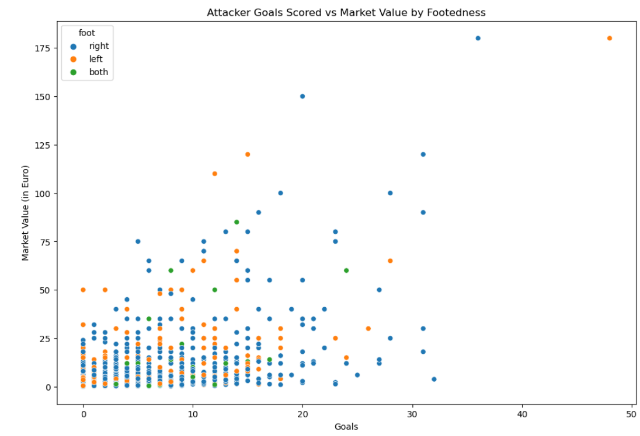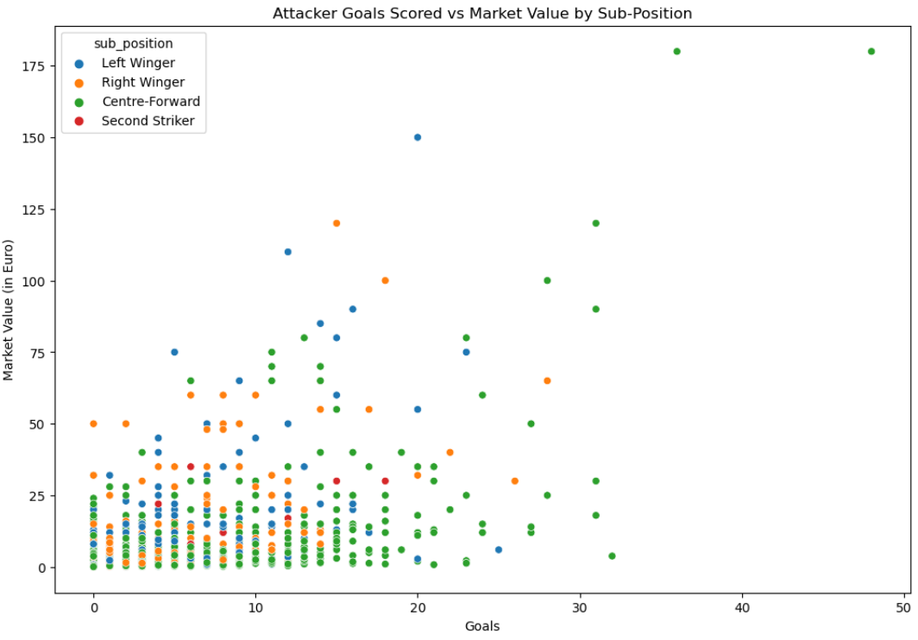

Figure 2.5. Individual attackers market values by goals and foot (left) and sub position (right)

#### Player Market Values by Goals Assisted

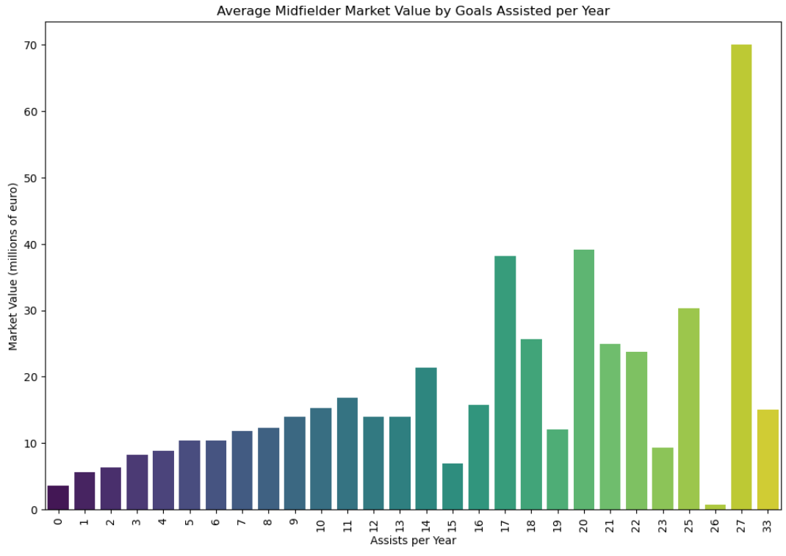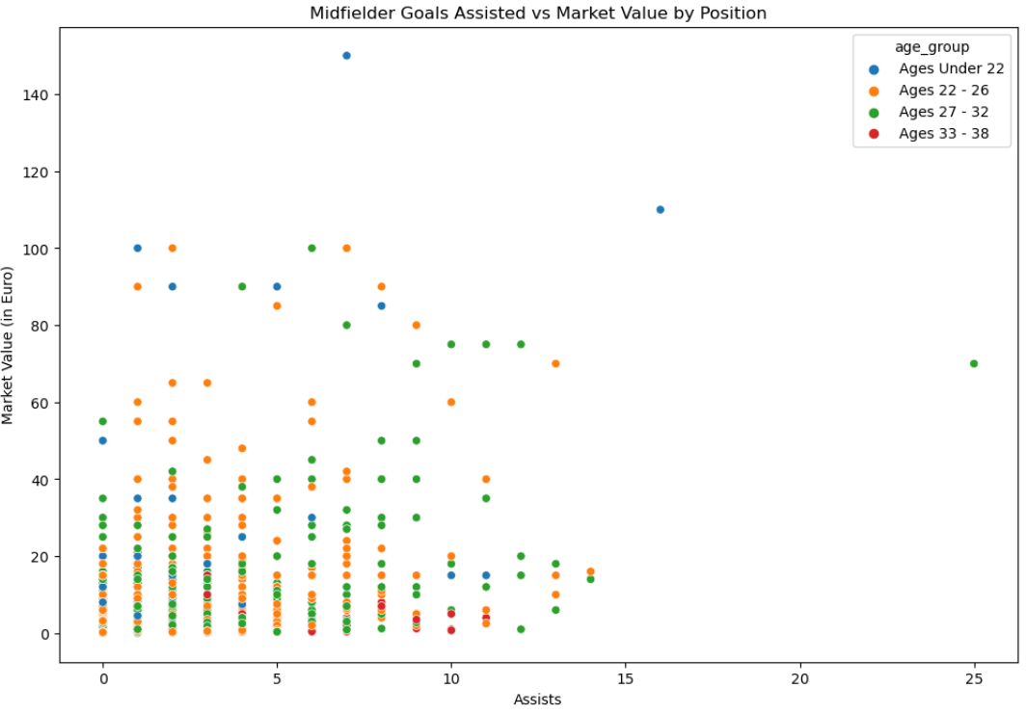

Figure 2.6. Averaged midfielder market values by assists(left) and individual midfielder market values by assist and age group (right)

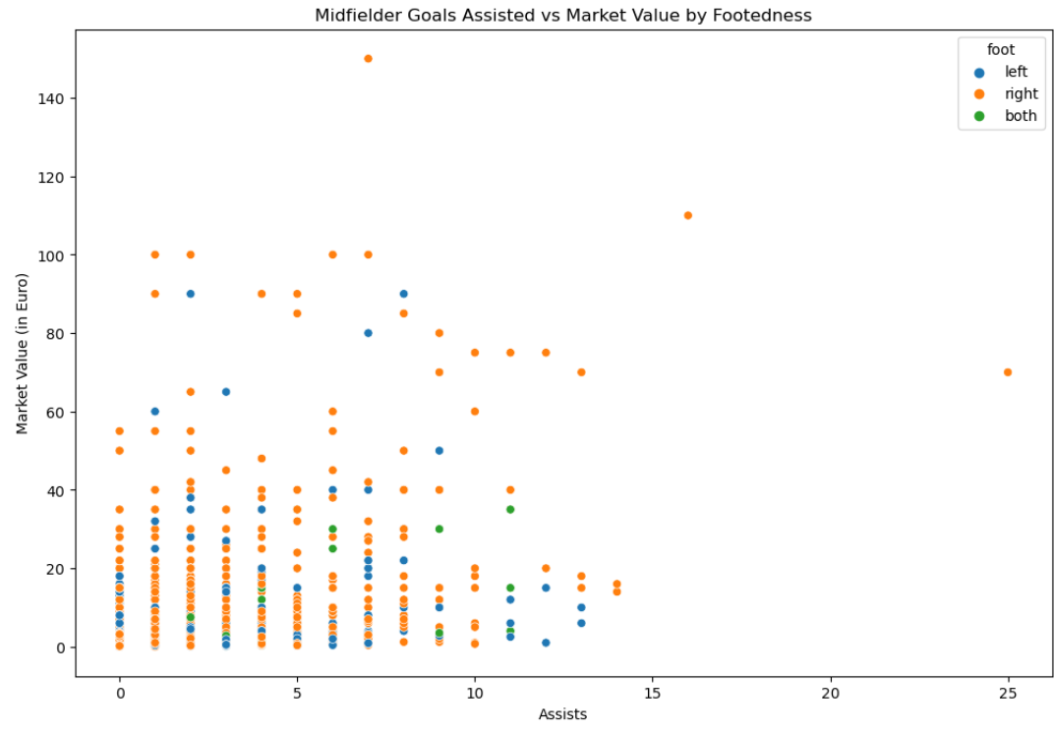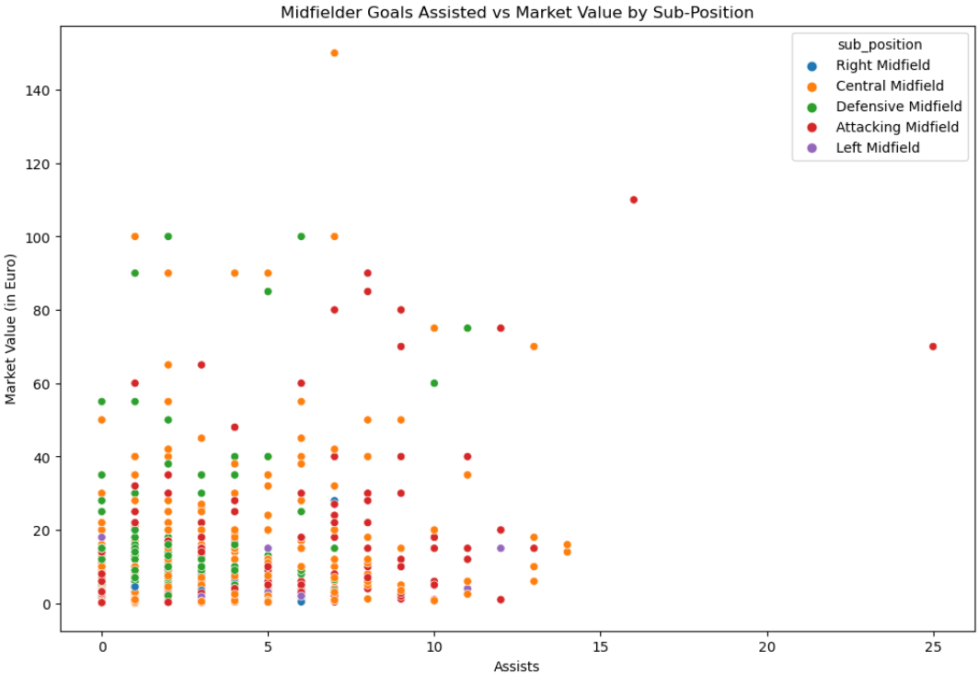

Figure 2.7. Individual midfielder market values by assists and foot (left) and sub position (right)

#### Player Market Values by Clean Sheets

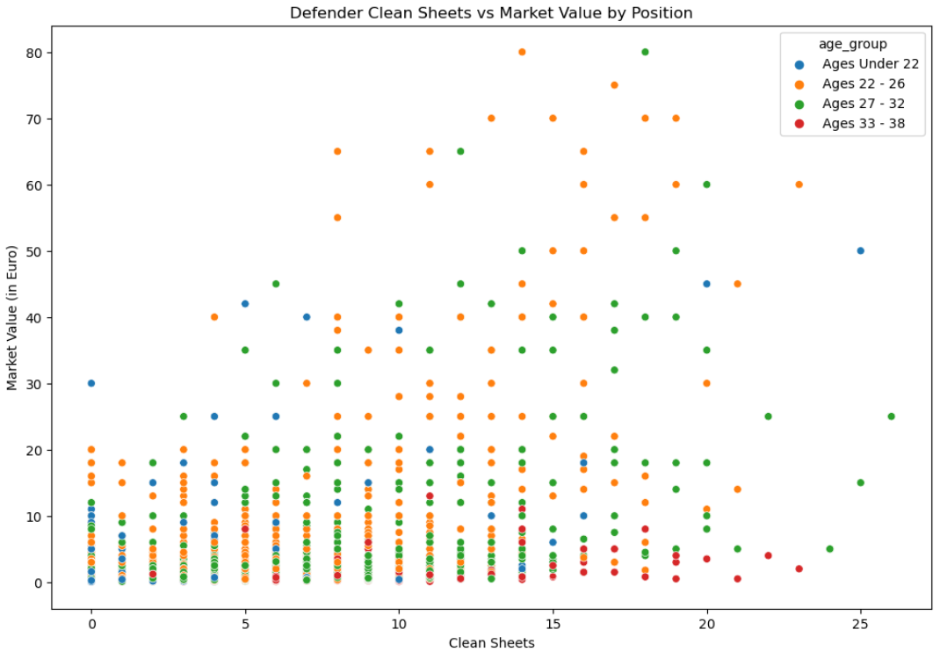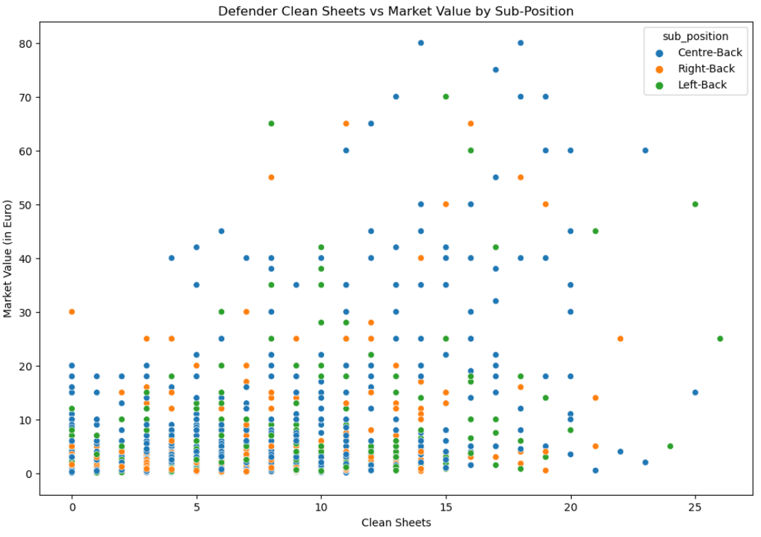

Figure 2.8. Individual defender market values by clean sheets and age group (left) and position (right)

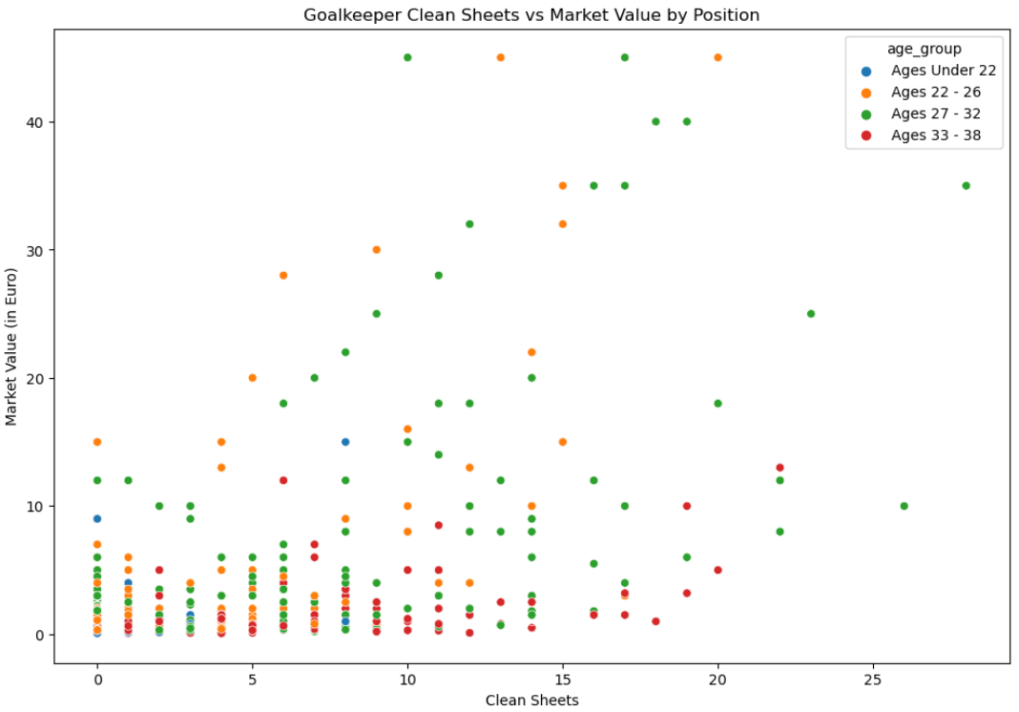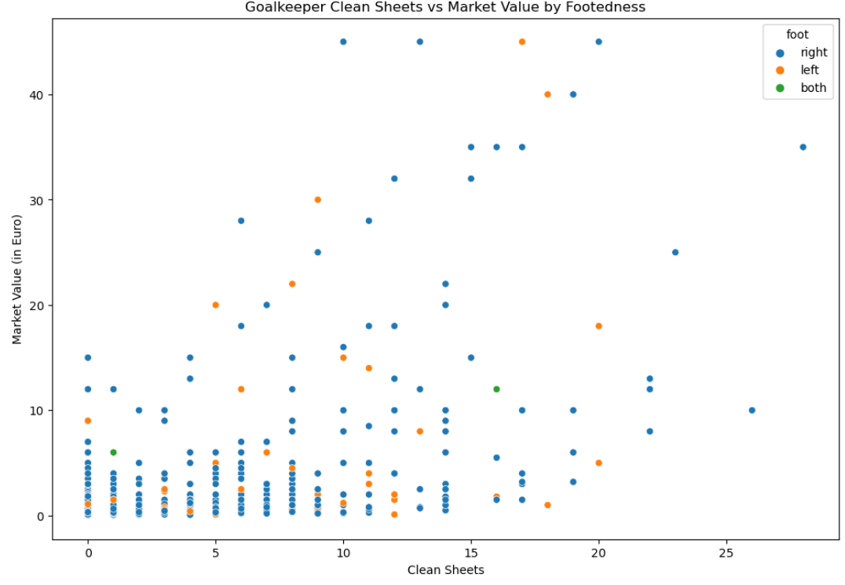

Figure 2.9. Individual goalkeeper market values by clean sheets and age groups (left) and footedness (right)

### Data Preprocessing

Data preprocessing is a crucial step in any Data Science projects lifecycle. It involves a number of operations and transformations being applied to raw data to make it suitable for analysis and modelling. The aim is to enhance the quality of the data by addressing missing or inconsistent values, handling various data types including number formatting and label encoding categorical variables, transforming the data using scaling, standardisation or normalisation techniques, and conducting feature engineering. Preprocessing is conducted in an iterative manner throughout the project. As previously discussed, outliers within the player height attribute were identified and replaced. The players dataset contained 10919 missing market values (figure 3.0). The player valuations dataset did not contain any. Original thoughts were to replace the missing values from the players dataset with those from the player valuations. On further investigation this proved futile as the players' valuation market values were inconsistent having been evaluated at different times. The next best option was to impute the missing values with the mean. The mean market values were thus grouped by player position and age group and a simple python function of conditional statements written to replace the missing values (figure 3.1).

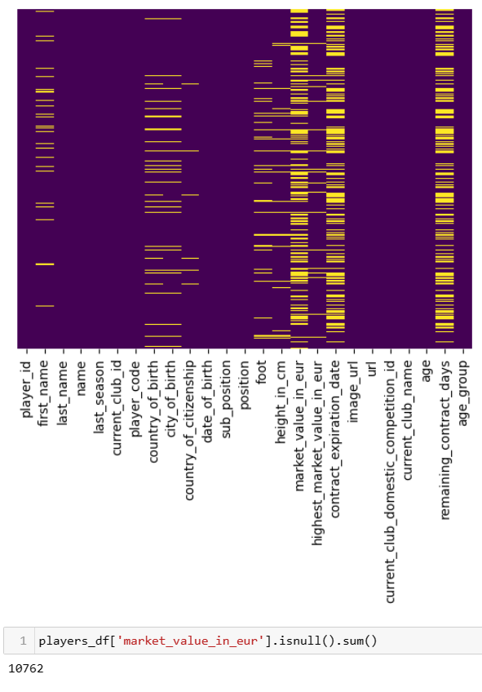

Figure 3.0. Heatmap of missing values for the players dataset

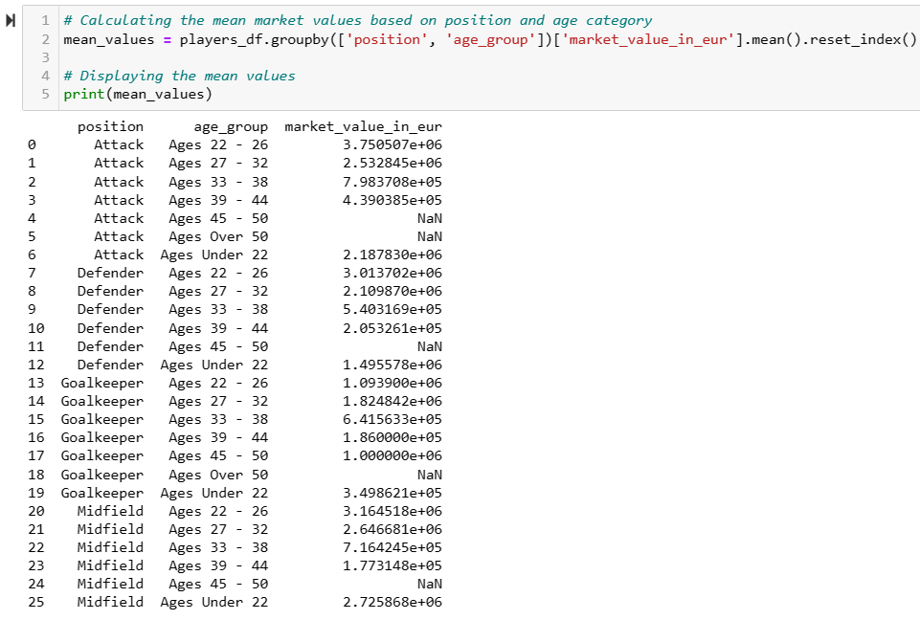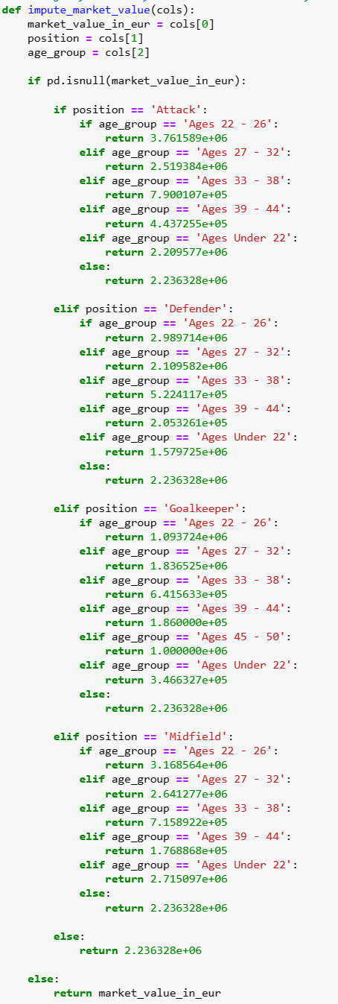

Figure 3.1. Mean values grouped by position and age group (left), Function for imputing mean values (right)

The same logic was used in imputing missing values for highest market value, player heights and remaining contract days attributes (Appendix B). As the foot feature is categorical, the mode is used to impute missing values based on a player's position and sub-position. EDA highlighted the inclusion of retired players within the data, who’s attributes, mainly market values, are inaccurate based on their current age, performance and the current market. Retaining them in the dataset would only introduce noise. They were therefore removed along with any features that would not aid in the Machine Learning (ML) process. Unique identifiers such as player names, player id’s, date of births, demographics and unrelated features like images and urls are all removed. Duplicate entries too were identified and removed. At this stage the dataset still contains valuable categorical features including, players positions and sub-positions, preferred foot, age-group and current clubs name and competition id’s. As the order or rank of these categories has no significance, one-hot label encoding is applied to create a new binary feature for each category and assign a value of 0 or 1 depending on whether the player belongs to that category.

For comparative purposes, multiple datasets are created based on features and the processes applied to them. Following one-hot label encoding, a smaller dataset of a select few categorical features (to avoid the curse of dimensionality) is created, a dataset of all categorical features and a dataset with features based on Pearson's Correlation. As the data contains outliers, a Robust Scaler is the first choice for scaling as it removes the median and scales the data according to the Interquartile Range (IQR) (Nalcin, 2022). MinMax Scaler is also applied for comparative purposes with new datasets created accordingly. It is worth noting that scaling is only applied to nonbinary numerical features so as to retain the value and impact of categorical features on the ML models.

### Feature Engineering

Feature engineering is an invaluable process in developing and enriching ML models. It includes feature generation, feature extraction and feature selection. Feature generation entails creating new features from the existing features within the dataset. These new features are engineered to provide additional information that may be relevant and useful to the problem at hand.

A feature for a player's age is created by casting the date of birth feature to datetime and subtracting it from an instantiated object of the current datetime before dividing by 365.25 for years. A feature for remaining contact days is created in a similar manner by calculating the difference between the current time and the contract expiration date feature. A feature to categorise players into age groups is created using a python function of conditional statements.

Further feature engineering includes creating features for goals, assists, yellow and red cards, minutes played, goals for, goals against and clean sheets for each of the last five years, as well as an accumulated total feature for each of these attributes. This was performed whilst merging the appearance, games and players datasets. Finally, features are engineered from the above features for minutes per a goal and minutes per an assist with the resulting NaN (not a number) and inf (infinity) values replaced with 1e400 to represent infinity. Unfortunately, these features are ultimately removed as they are too large for processing.

Feature extraction is the process of reducing the size or dimensionality of a large dataset while feature selection involves choosing a subset of the most relevant features by removing redundant or irrelevant rows that may introduce noise or lead to overfitting (Rahul Kumar, 2019). To aid in feature selection, statistical testing is applied. Pearson's Correlation coefficients are generated to measure the correlations between independent variables to the target variable, ‘market_value_in_eur’. It is well known that correlation does not necessarily equate to causation. However, for this refined dataset we may assume it does, as a player's market value is derived from its features, and itself, has no influence on them. As such we are measuring the causal relationships. There is no universal correlation coefficient threshold value for retaining features, this is rather determined by domain knowledge and per use case. A refined dataset of the highest correlated feature was created on the first iteration. We found no improvement in model results, and chose to proceed with all numerical features on this second iteration. For feature selection of the categorical variables, Analysis of Variance (ANOVA), or two way factorial Analysis of Variance to be precise is tested (qualtrics, n.d.). ANOVA is an extension of the t-test for independent samples, for more than two groups. It measures the difference in mean between the different categories of the independent variable with respect to the dependent variable (qualtrics, n.d.). The null hypothesis (H0) of ANOVA is that there is no statistical difference among the group means. If a difference exists, it has occurred “by chance”. On the other hand, the alternative hypothesis (Ha) is that at least one group differs significantly from the overall mean of the target variable (Kalyvas, 2024). ANOVA assumes a normal distribution, as such, is tested against the log transformation of the target variable. With all resulting p-values below a 0.05 (5%) significance level, we conclude that they all influence the target variable, and are thus retained.

The numerical features with a correlation greater than 0.4 to market value (with 1 being the maximum for positive correlation) can be seen in the figure 3.2 below. Correlation between features for the full dummies dataset can be found in appendix C. It was surprising to find that many of the categorical features for player position and age group do not rank high for correlation to the target variable, player market value. Playing in the premier league or for one of the bigger clubs in Europe does however contribute to market value. A new dataset following feature selection on Pearson correlation is created.

### Model Selection

Model selection is choosing the appropriate machine learning algorithm based on the objective at hand. The objective is to predict the market value of players which is continuous data, making this a regression problem. Furthermore, we are using labelled data making this a supervised ML application. Many supervised ML algorithms offer classification and regression variants, with some excelling in one over the other. It is important to note that when developing a ML model, it is extremely unlikely to produce an optimal model on a first attempt. It is about trial and error, and continuous development and improvement. A linear regression model will be implemented as a based model, followed by Kernel Ridge (KR) with different kernels applied for multiple linear regression. Random Forest Regressor (RFR) and Gradient Boosting Regressor (GBR) are also selected based on positive results found through literature reviews on similar applications(www.kaggle.com, n.d.).

### Training and Validation

This step requires splitting the dataset into training and validation sets. The training set which allows the model to learn and the validation set on which we test how well the model has learned. Multiple instances of different training to validation set ratios are tested including 70:30, 80:20 and 90:10 while studying the training error, validation error and evaluation metrics. It is not uncommon for ML practitioners to split the dataset into three subsets, one each for training, validation/development and testing. The development set can be used to assess different models performance, tune parameters and minimise overfitting ( Rahul Kumar, 2019). A validation set is tested with early stopping via hyperparameter tuning for GBR.

In selecting and training a model it is important to be aware of overfitting, underfitting, bias and variance. Overfitting occurs when you fit a model too precisely to the particularities of the training set, thereby obtaining a model that works well on the training set but is not able to generalise to new data. Essentially, the model is memorising the training data instead of learning the relationships within it. This can occur when a model is too complex and learns the noise in the data instead of the underlying pattern. Having a complex model and too many features can also lead to high variance and low bias. Underfitting on the other hand occurs when a model is too simple and does not capture the underlying pattern in the data. An underfitting model with too few features will have low variance and high bias. Bias refers to the difference between the expected value of a model's prediction and the actual value. When a model makes test predictions, bias leads it to make inaccurate estimates. Variance refers to how much a model is dependent on the training data. It refers to the amount by which a model's prediction may vary for different training sets. Finding the right balance between bias and variance is essential in developing a model that generalises well. Generalisation refers to the ability of a model to perform well on new data. This means that the model is not underfitting nor overfitting and can be achieved by balancing the complexity of a model with the amount of training data available. Cross validation is used to estimate the ability of a model to generalise to new data. K-fold cross-validation is the process of splitting the data into k-many folds. A series of training and testing is then applied, holding one split of the data as the test set and the remainder as the training set. The test and training split are alternated k times, each time using a different fold for validation. An average score is calculated based on each fold to determine the overall performance of a given model. Cross validation is more stable and thorough than using a split in training and test set (Müller and Guido, 2017).

### Evaluation Metrics

Here we will define metrics to evaluate the performance of each model. For regression problems, Sklean provides Mean Absolute Error (MAE), Mean Squared Error (MSE), Root Mean Squared Error (RMSE) and R-squared (R²) for more advanced metrics, with R² being more intuitive and the preferred choice in evaluating regression models (Müller and Guido, 2017). Without delving too deep into the mathematics behind each metric, MAE measures the average absolute differences between predicted and actual values. MSE calculates the average of the squared differences between predicted and actual values. RMSE is the square root of MSE while R² measures the proportion of variance in the target variable that is predictable from the independent variables. R² ranges from 0 to 1 with a score of 1 indicating a perfect fit. For, MAE. MSE and RMSE, lower values indicate better performing models. 5-fold Cross Validated Mean R² (CV Mean R²) will be the determining metric for this project.

### Tune Hyperparameters

Hyper parameter tuning is the process of selecting the optimal set of hyperparameters for a machine learning model. This is an important step in the development of a model as the choice of parameters can have a significant impact on performance. Manual and Random Search are both utilised in optimising the KR and GBR models. For GBR applying the suggested values from Random Search did not contribute to a better model. Hyperparameters such as n_estimators, learning_rate, max_features, max_depth, min_samples_split, min_samples_leaf, n_iter_no_change, subsample and validation_fraction are all adjusted for GBR in attempts to counter overfitting while optimising CV Mean R². For KR, alpha, gamma, degree, coef0 and the kernel are all adjusted in optimising the model with positive results.

### Predictive Analytics

Once satisfied with the training and performance of a model, it can be used to make predictions on new data.

### Visualisation

Visualisations and graphs are used throughout the development process in EDA, feature engineering, modelling and finally to communicate the research findings effectively. Open source libraries like matplotlib and seaborn in Python are used in a Jupyter Notebook in developing and documenting the process.

### Continual Improvement

Multiple iterations of the CRISP-DM lifecycle may be necessary to reassess and refine the model based on new data or insight, and to ensure that the project remains on track in achieving its objectives.

### Boundaries and Limitations

It is important to note that each club is unique and so to their structure, ambitions and vision. What is right for one club may not be for another. Some aspire to win the league while others to avoid relegation. Other business models may depend solely on selling players for profit (Sloane, cited in Van den Berg, 2011). Hence aligning and framing scouting requirements with the vision of a club is crucial, as is the recognition that talent id is one small part of squad evolution and building. Another challenge may reside in harnessing the data and bringing together different data sources. There are multiple factors that contribute to evaluating a player's value, some of which may not be available within the selected dataset. Aspects such as exchange rates and social or economical factors like war, recession or a worldwide pandemic may prove challenging to account for (Metelski, 2021).

# Results

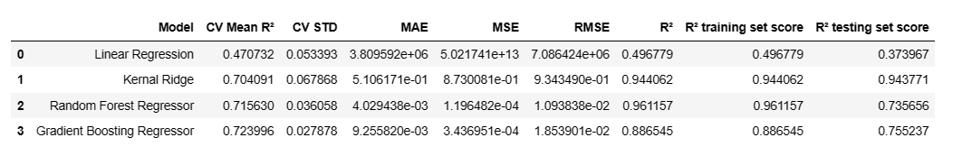

Figure 3.4. Table of Model Results

The best results for KR, RFR and GBR can be seen in figure 3.4 above and easily compared to the base model results from the LR model. The first LR model's results are poor which is expected as it is a linear model being applied for multiple linear regression on nonlinear data. The model is underfitting with poor training and testing results. RFR produced an overfitting model with a high training score of 0.961157 and a low test score of 0.735656 relative to training. The most promising results were provided by GBR and KR. GBR provided a CV Mean R² of 0.715630 following 5-fold cross validation with the lowest standard deviation. However the model is clearly overfitting to the training data with a considerable difference in training to testing results. KR produced a CV Mean R² of 0.704091, a training R² score of 0.944062 and a testing R² score of 0.943771. Although both results are high, they are very close which likely indicates underfitting. This is further evident in the learning curve below.

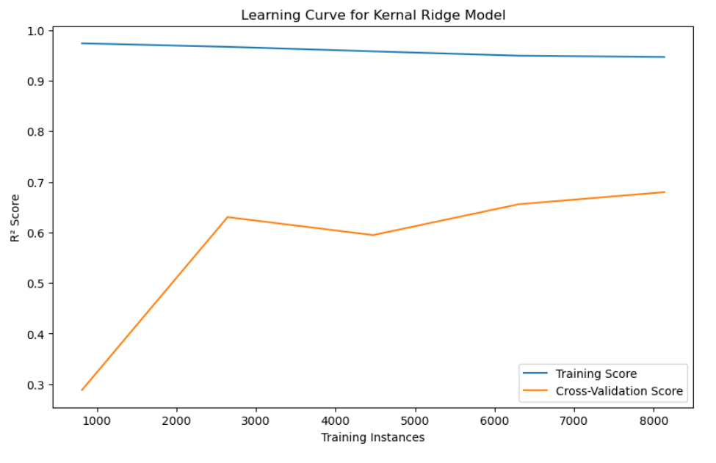

Figure 3.5. Learning curve for Kernel Ridge Model

The learning curve does offer hope for future improvement as it indicates an increase in scores with an increase in data (Brownlee, 2019).

# Timeline

* Data preprocessing and cleaning: 6 weeks
* Feature engineering: 6 weeks
* Model selection: 5 weeks
* Training and validation: 6 weeks
* Tuning hyperparameters and defining evaluation metrics: 4 weeks
* Predictive analytics and model testing: 4 weeks
* Producing visualisations: 5 weeks
* Documentation and reporting: 3 weeks

This is a very high level timeline with approximate estimates on time that ensures a phased approach to the project.

# Conclusion

Player scouting and market value analysis are key areas where ML can provide valuable knowledge and insights to the football industry. This capstone project aims to contribute to this by empowering clubs and stakeholders with data driven decision making capabilities for a competitive advantage. By leveraging machine learning on the “Football Data from Transfermarkt” dataset, the project aligns with the evolving landscape of sports analytics, providing practical solutions to real world challenges in the football industry. This first iteration of the CRISP_DM life cycle has proved challenging due to time and computational restraints. The results however are quite promising. The project has plenty of scope for improvement at each step of the development process. Different techniques can be applied in preprocessing, including alternative scaling methods. Additional feature engineering including dimensionality reduction through PCA, feature generation by resolving the infinity problem and feature selection through Random Forest feature importance. Each model can be further optimised through hyperparameter tuning via Grid Search CV as well as implementing new and untested models like ANN.

Three Jupyter notebooks documenting the process and python code are created, one each for EDA, Preprocessing and Modelling. Unfortunately the Preprocessing notebook is too large to be pushed to the Github repository. A pdf of the notebook has been uploaded instead.

Github: <https://github.com/KaviCCT/Strategic_Thinking_CA2>

# Appendix A

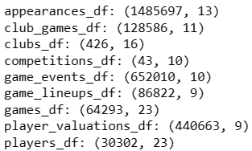

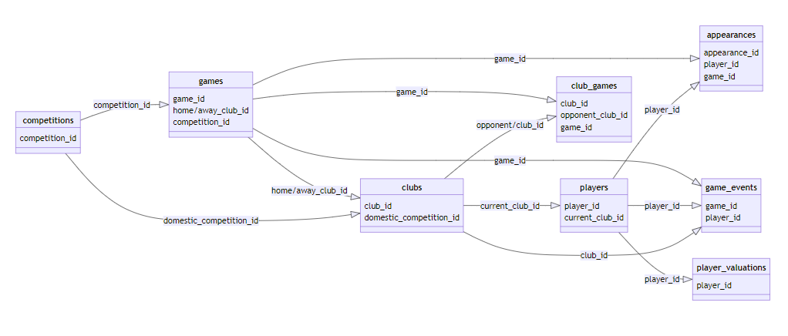

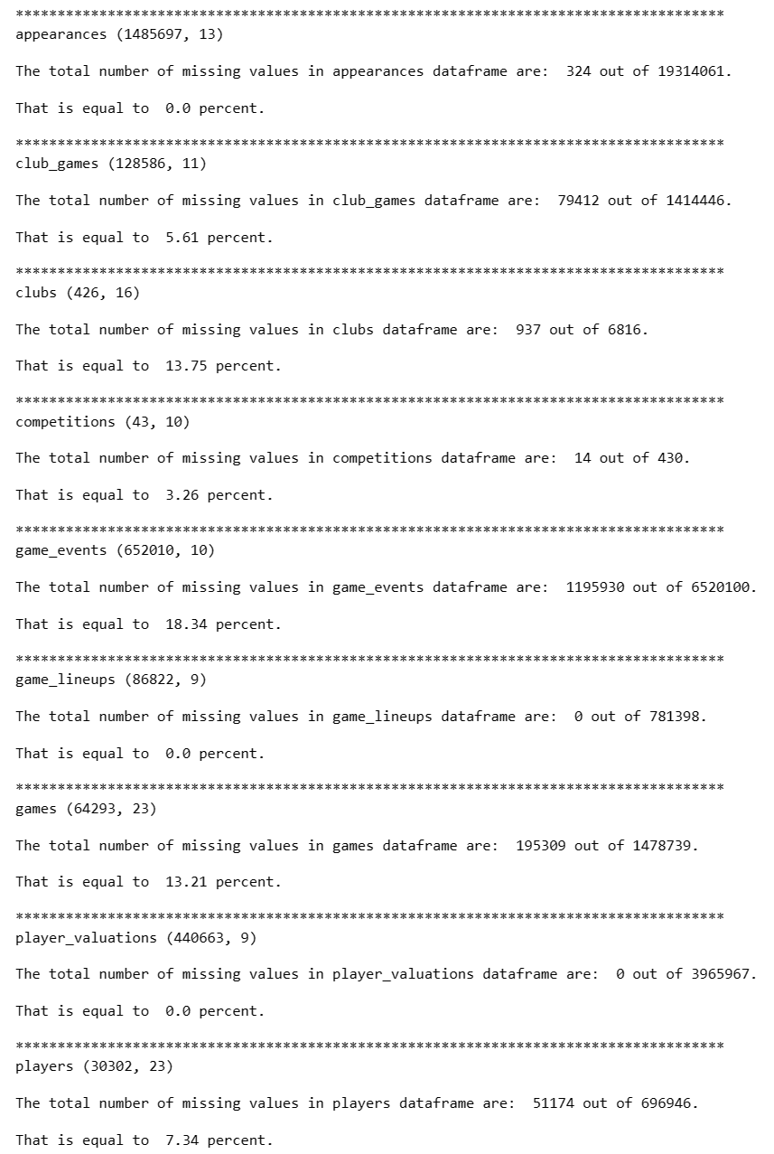

Figure 1.1. Dataset names, shapes and missing values

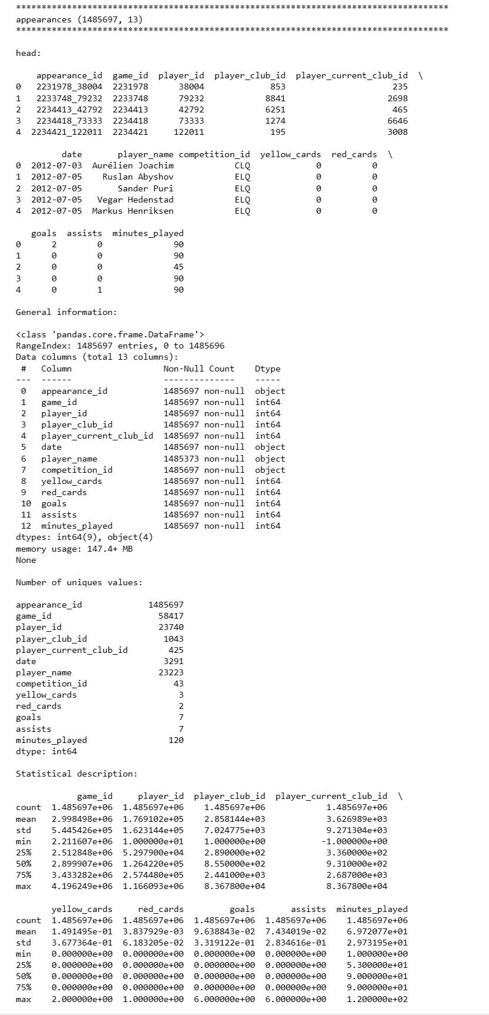

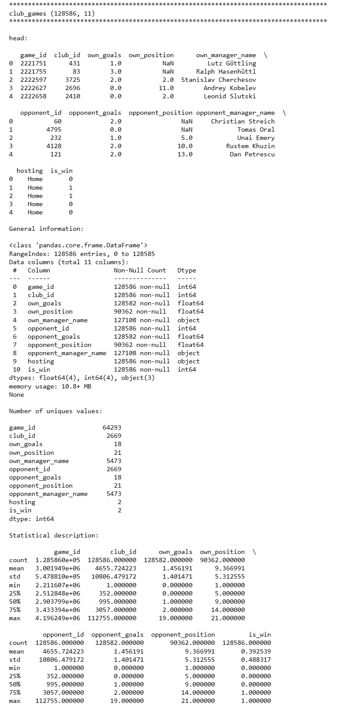

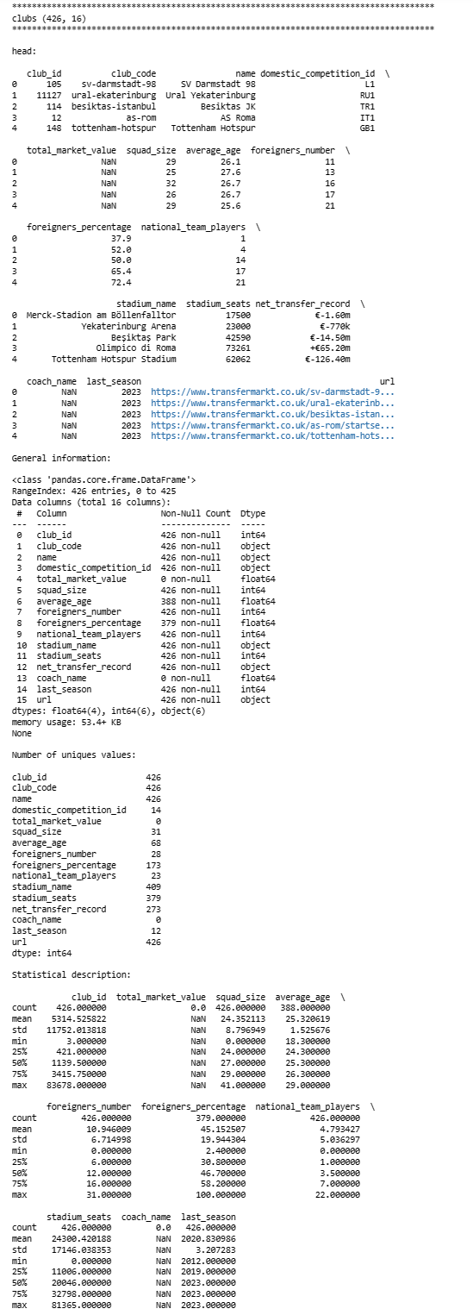

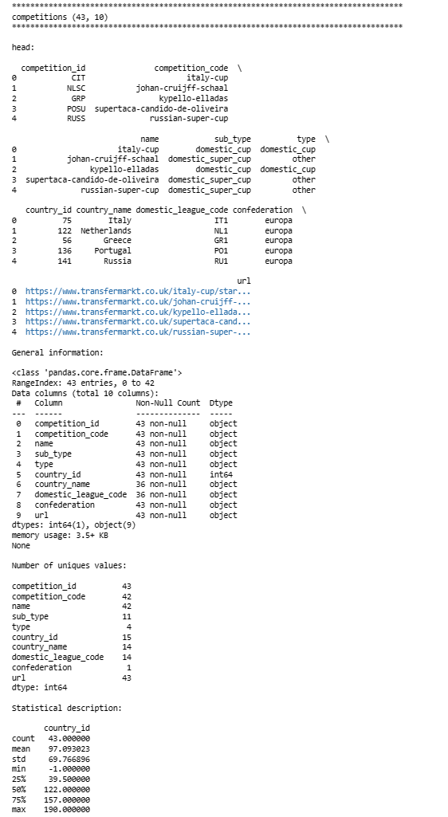

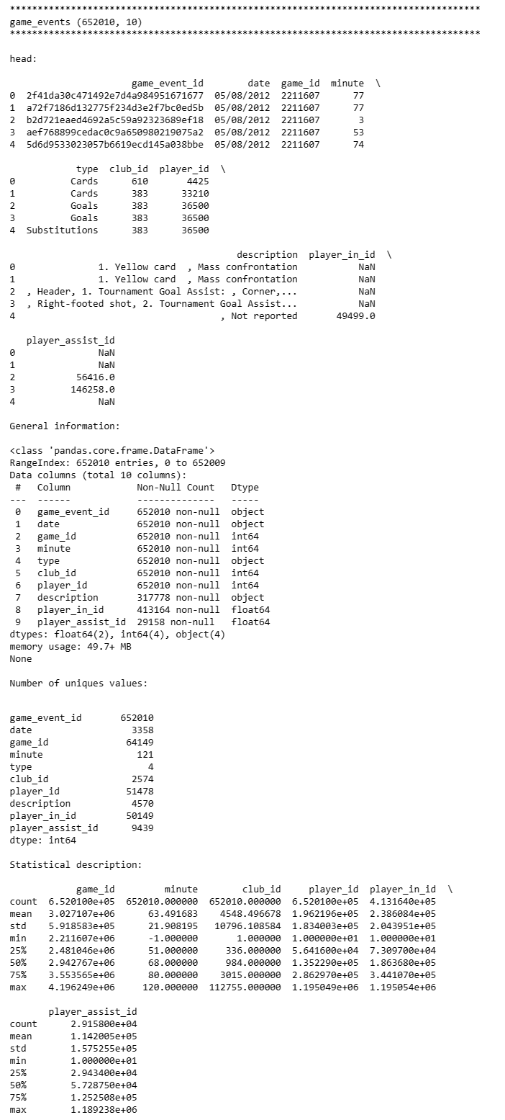

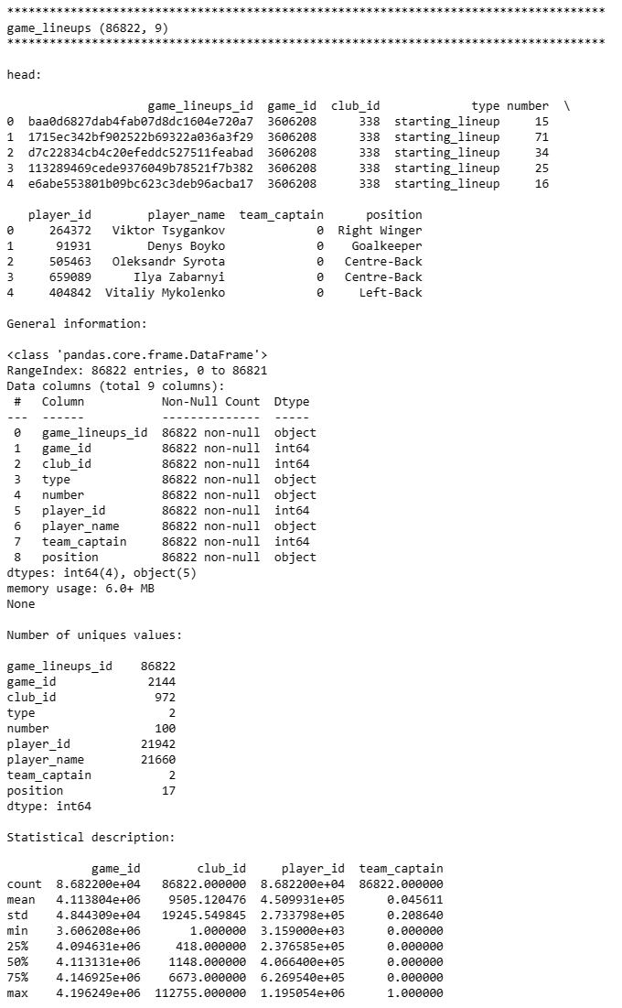

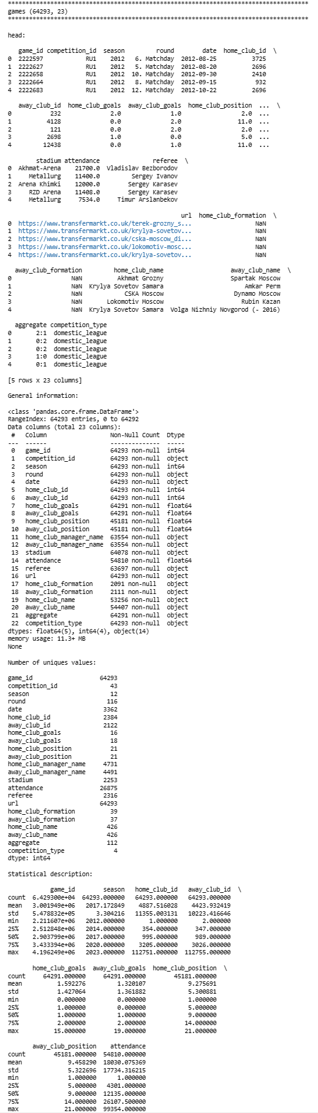

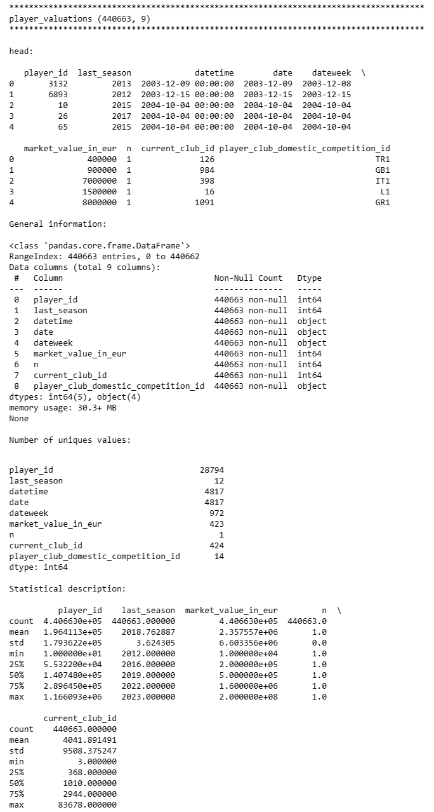

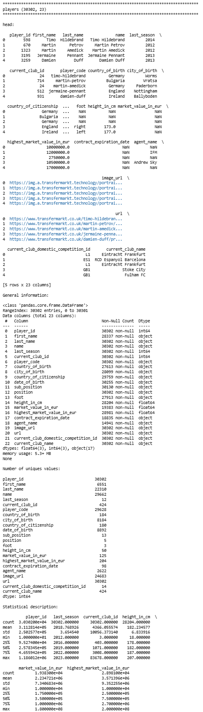

# Appendix B

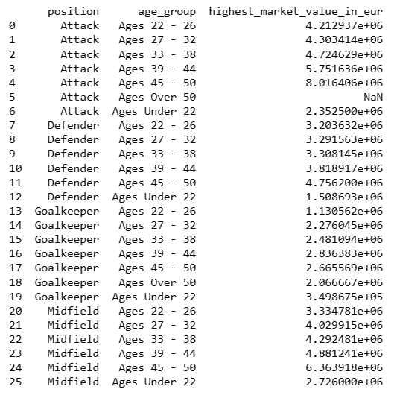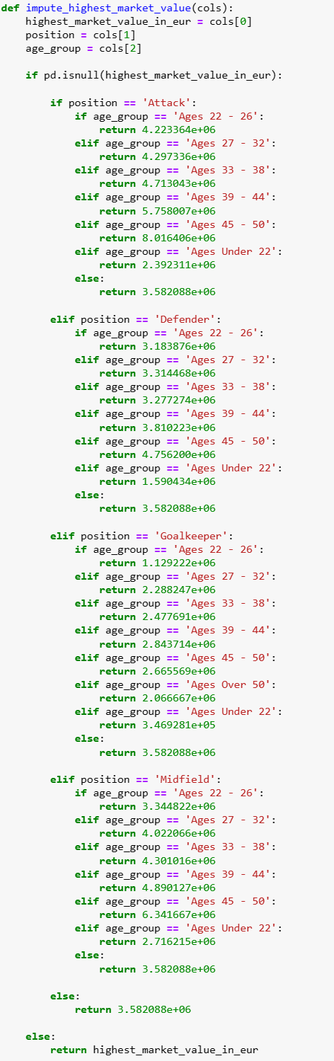

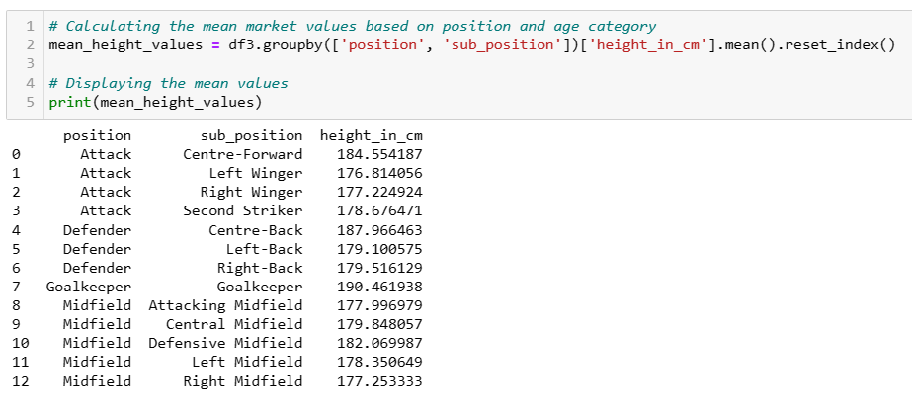

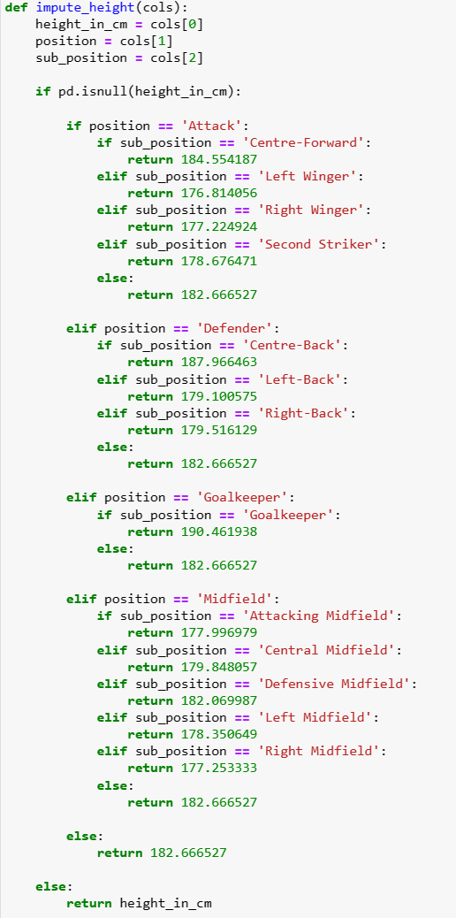

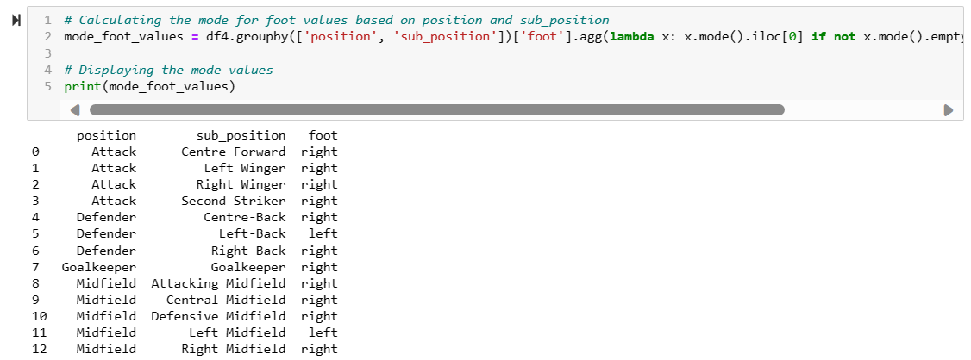

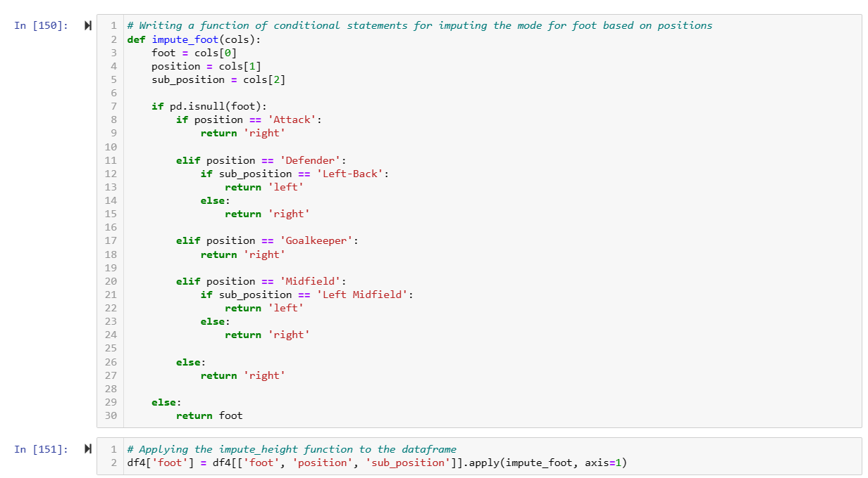

# 

# Appendix C

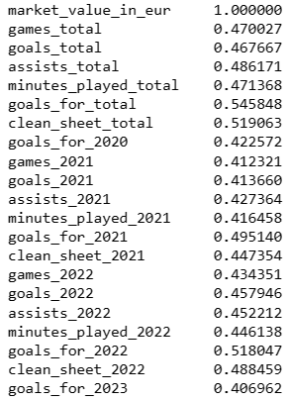

Figure 3.2. Results for Pearson Correlation on Numerical Features

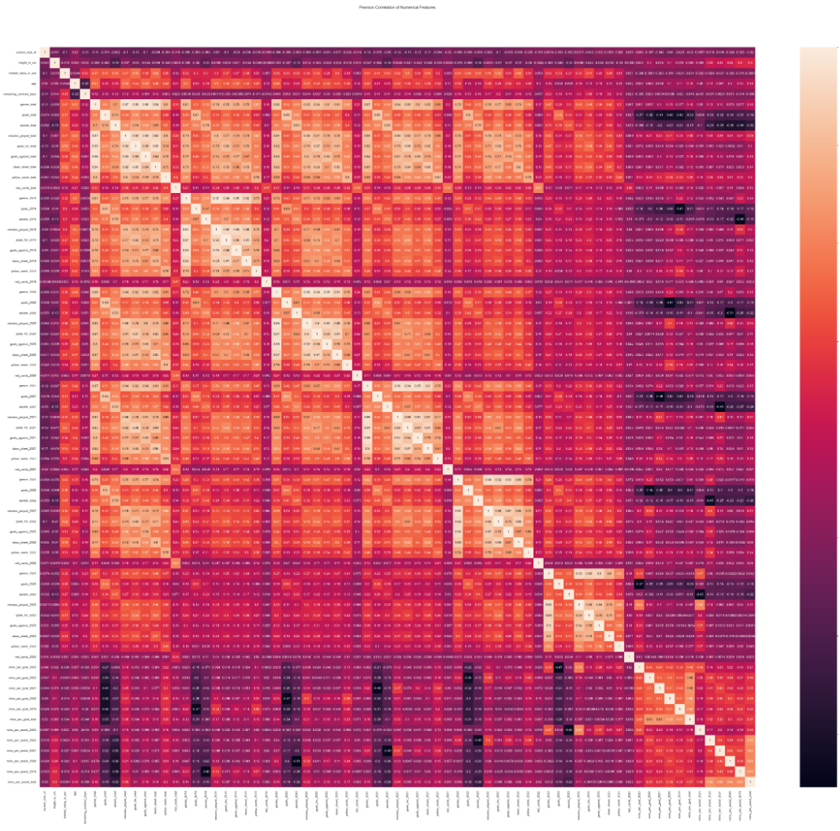

Figure 3.3. Heatmap of Pearson's correlation between variables

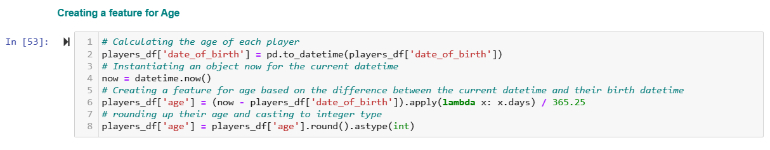

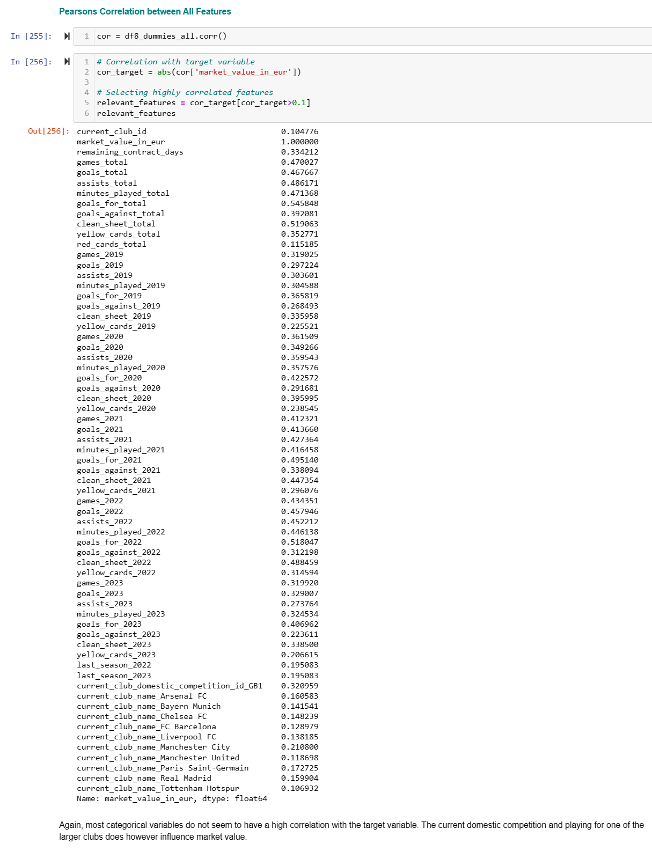

# Appendix D

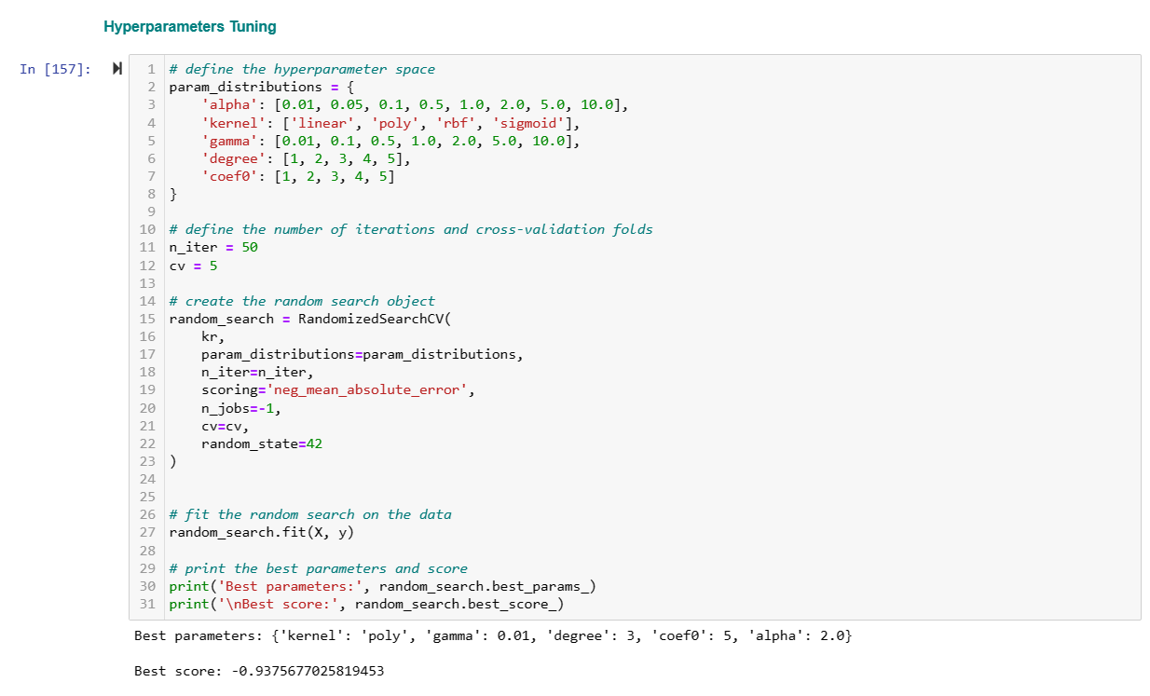

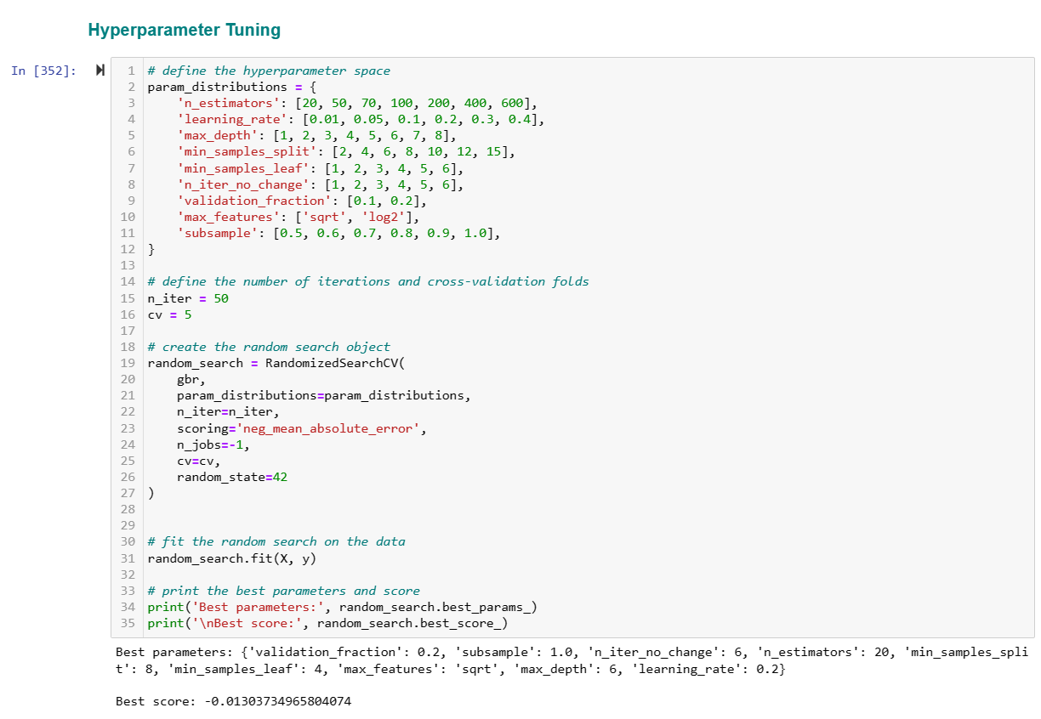

# References

Agnellutti, C. (2014) Big Data: an Exploration of Opportunities, Values, and Privacy Issues. New York: Nova Science Publishers, Inc (Internet Theory, Technology and Applications). Available at: <https://search.ebscohost.com/login.aspx?direct=true&db=e020mww&AN=811106&site=eds-live>

Ahmed, T. (n.d.). CCT College Dublin: Log in to the site. [online] moodle.cct.ie.

Available at: <https://moodle.cct.ie/course/view.php?id=2637> [Accessed 20 Dec. 2023].

Brownlee, J. (2019). A Gentle Introduction to Learning Curves for Diagnosing Machine Learning Model Performance. [online] Machine Learning Mastery.

Available at: <https://machinelearningmastery.com/learning-curves-for-diagnosing-machine-learning-model-performance/>.

Campbell, F. (2019). Data Scraping – Considering the Privacy Issues. [online] Fieldfisher. Available at: <https://www.fieldfisher.com/en/services/privacy-security-and-information/privacy-security-and-information-law-blog/data-scraping-considering-the-privacy-issues>.

Cordeiro, L. (n.d.). Market Value EDA 📈⚽💸. [online] kaggle.com. Available at: https://www.kaggle.com/code/luisgasparcordeiro/market-value-eda/notebook [Accessed 22 Dec. 2023].

Coxen, D. (n.d.). Football Transfer Market EDA & Basic Modelling. [online] kaggle.com. Available at: <https://www.kaggle.com/code/davidcoxon/football-transfer-market-eda-basic-modelling> [Accessed 19 Dec. 2023].

Depken, C.A. and Globan, T. (2020). Football Transfer-Fee Premiums and Europe’s Big Five: Online Appendix. SSRN Electronic Journal. doi:<https://doi.org/10.2139/ssrn.3617260>.

Goundar, S. (2021). Enterprise systems and technological convergence : research and practice. [online] Charlotte, NC:

<https://eds.p.ebscohost.com/eds/ebookviewer/ebook/ZTAyMG13d19fMjczMDYwNF9fQU41?sid=997bf805-38e3-47f1-bfb3-813e10171b3f@redis&vid=3&format=EB>

Metelski, A. (2021). Factors affecting the value of football players in the transfer market. Journal of Physical Education and Sport, 21(2). doi:<https://doi.org/10.7752/jpes.2021.s2145>.

Müller, A.C. and Guido, S. (2017). Introduction to machine learning with Python : a guide for data scientists. Beijing: O’reilly.

Nalcin, S. (2022). StandardScaler vs. MinMaxScaler vs. RobustScaler: Which one to use for your next ML project? [online] Medium. Available at: <https://medium.com/@onersarpnalcin/standardscaler-vs-minmaxscaler-vs-robustscaler-which-one-to-use-for-your-next-ml-project-ae5b44f571b9>.

Niu, Y., Ying, L., Yang, J., Bao, M. and Sivaparthipan, C.B. (2021). Organisational business intelligence and decisionmaking using big data analytics. Information Processing & Management, [online] 58(6), p.102725. doi:<https://doi.org/10.1016/j.ipm.2021.102725>.

Pannucci, C.J. and Wilkins, E.G. (2011). Identifying and Avoiding Bias in Research. Plastic and Reconstructive Surgery, [online] 126(2), pp.619–625. doi:<https://doi.org/10.1097/prs.0b013e3181de24bc>.

Patak, K. (2023). Strategic Analysis of Emerging Technology for Competitive Advantage: Artificial Intelligence in the Football Industry. [online] Available at: <https://drive.google.com/file/d/1g7y_U2cSYDq771WJZoka4AvgIkdOvIW7/view?usp=sharing> [Accessed 27 Oct. 2023].

Persson, J. and Sjöö, E. (2017). Business Intelligence - its impact on the decision making process at higher education institutions.

Rahul Kumar (2019). Machine learning quick reference : quick and essential machine learning hacks for training smart data models. Packt Uuuu-Uuuu.

Solon Barocas and Selbst, A.D. (2015). Big data’s disparate impact. Ssrn Elibrary.

Scikit-learn.org. (2018). Compare the effect of different scalers on data with outliers — scikit-learn 0.20.3 documentation. [online] Available at: <https://scikit-learn.org/stable/auto_examples/preprocessing/plot_all_scaling.html>.

Solon Barocas and Selbst, A.D. (2015). Big data’s disparate impact. Ssrn Elibrary.

Suresh Kumar Mukhiya and Ahmed, U. (2020). Hands-on exploratory data analysis with Python : perform EDA techniques to understand, summarize, and investigate your data smartly. Birmingham: Packt Publishing.

wiki.creativecommons.org. (n.d.). CC0 FAQ - Creative Commons. [online]

Available at: <https://wiki.creativecommons.org/wiki/CC0_FAQ>.

Van den Berg, E. (2011). The Valuation of Human Capital in the Football Player Transfer Market. [online]

Available at: [Link](https://d1wqtxts1xzle7.cloudfront.net/6177574/berg__e._van_den__296332_-libre.pdf?1390844876=&response-content-disposition=inline%3B+filename%3DThe_Valuation_of_Human_Capital_in_the_Fo.pdf&Expires=1698586960&Signature=Y6SAWE8dDwH7y7ufin5qpNIwpIKoAHkam~bVdYd-Hua7-sofcQOPoHTyyeB7eOFRp67FiQm34FDIHNAkmGzy5jy2dCtstGfCy-8hzjPIuRFj3jVXdf7cLMHrI7TOJWzVugUFtYKNJe3zngLuydJ0TyT3JaHXJdCtVmgL4KsQjDnOtkbBy6Ajb-78Sj1~EtsJJWnHRcmeTRqq-M6mW~Wl7bTnP-mQHlM4ZopEqv3Z-nTEoCpqpIb4gZvI-mlF4LDSFA8DnZNO6l9TsUJz1CKpnMvbbsKm~9y0L4c4Ha3dEDZ4eyvGLfxzaKQF7IC72DFXJCKoPXNfzuzRfpb5uYTASg__&Key-Pair-Id=APKAJLOHF5GGSLRBV4ZA)

wiki.creativecommons.org. (n.d.). CC0 FAQ - Creative Commons. [online] Available at: <https://wiki.creativecommons.org/wiki/CC0_FAQ>.

Wirth, R. and Hipp, J. (2000). CRISP-DM: Towards a Standard Process Model for Data Mining . Proceedings of the 4th international conference on the practical applications of knowledge discovery and data mining, (Vol. 1, pp. 29-39).

World Population Review (2022). Most Popular Sport by Country 2020. [online] worldpopulationreview.com.

Available at: <https://worldpopulationreview.com/country-rankings/most-popular-sport-by-country>

www.footballbenchmark.com. (n.d.). Football Benchmark - Methodology and limitations of published information. [online] Available at: <https://www.footballbenchmark.com/methodology/player_valuation>.

www.kaggle.com. (n.d.). Football Data from Transfermarkt. [online] Available at: <https://www.kaggle.com/datasets/davidcariboo/player-scores/versions/284/data> [Accessed 29 Oct. 2023].

www.transfermarkt.co.uk. (n.d.). Aïssa Boudechicha - Player profile 23/24. [online] Available at: <https://www.transfermarkt.co.uk/aissa-boudechicha/profil/spieler/592398> [Accessed 16 Dec. 2023].

www.transfermarkt.co.uk. (n.d.). Genar Fornés - Player profile 23/24. [online] Available at: <https://www.transfermarkt.co.uk/genar-fornes/profil/spieler/628490> [Accessed 5 Dec. 2023].

**_________________________________________________________________________**